

## *Gold Creek, Montana*

## Applications available online

Late January for Spring sessions

Mid-March for Summer sessions

Early June for Fall sessions

Volunteer & Presenter applications

Mid to Late March for all sessions

<https://www.campdream.org/apply/>

**WINTER**

**February 19-21 Family Camp**

Montana families affected by cancer (survivor, parents, siblings)

*Partner program with Cancer Support Community of MT*

**SPRING**

**April 21-24 Caregivers Retreat**

Cancer survivor and their caregiver (ages 21+)

**May 12-16** **Ovarian & Women’s Cancer Retreat**

Women diagnosed with any type of cancer (ages 21+)

**SUMMER**

**June 7-12** **Young Adult Conference**

Young adults diagnosed with cancer (ages 18-35)

**June 16-21** **Heads Up Conference**

Young adults diagnosed with a brain tumor (ages 18-35)

*Partner program with Children’s Brain Tumor Foundation*

**July 6-11**  **Kids & Young Siblings Camp**

Children diagnosed with cancer & siblings/children of cancer patients (ages 6-12)

**July 15-20 Teen Siblings Camp**

Teen siblings and/or children of cancer patients (ages 13-18)

**July 25-30** **Teen Heads Up Conference**

Teenagers diagnosed with a brain tumor (ages 13-18)

*Partner program with Children’s Brain Tumor Foundation*

**Aug. 3-8 Teen Camp**

Teens diagnosed with cancer (ages 13-18)

**Aug. 11-14 Family Camp**

Families affected by cancer (survivor, parents, siblings)

**FALL**

**Aug. 25-29 Ovarian Cancer Retreat**

Women diagnosed with Ovarian cancer (ages 21+)

**Sept. 8-12 Women’s Cancer Retreat**

Women diagnosed with any type of cancer (ages 21+)

**Sept.29-Oct.2 Caregivers Retreat**

Cancer survivor and their caregiver (ages 21+)

**Oct. 21-23 Professional Caregivers Retreat**

Medical & professional caregivers

2022 Cost-Free Programs

***Open to cancer patients in or out of treatment***

## 

## 

Learn more about:

* Programs
* Applying to be a participant
* Volunteering
* Summer staff positions
* Being a presenter at camp
* Ways you can help

Contact us:

[www.campdream.org](http://www.campdream.org)

(406) 549-5987

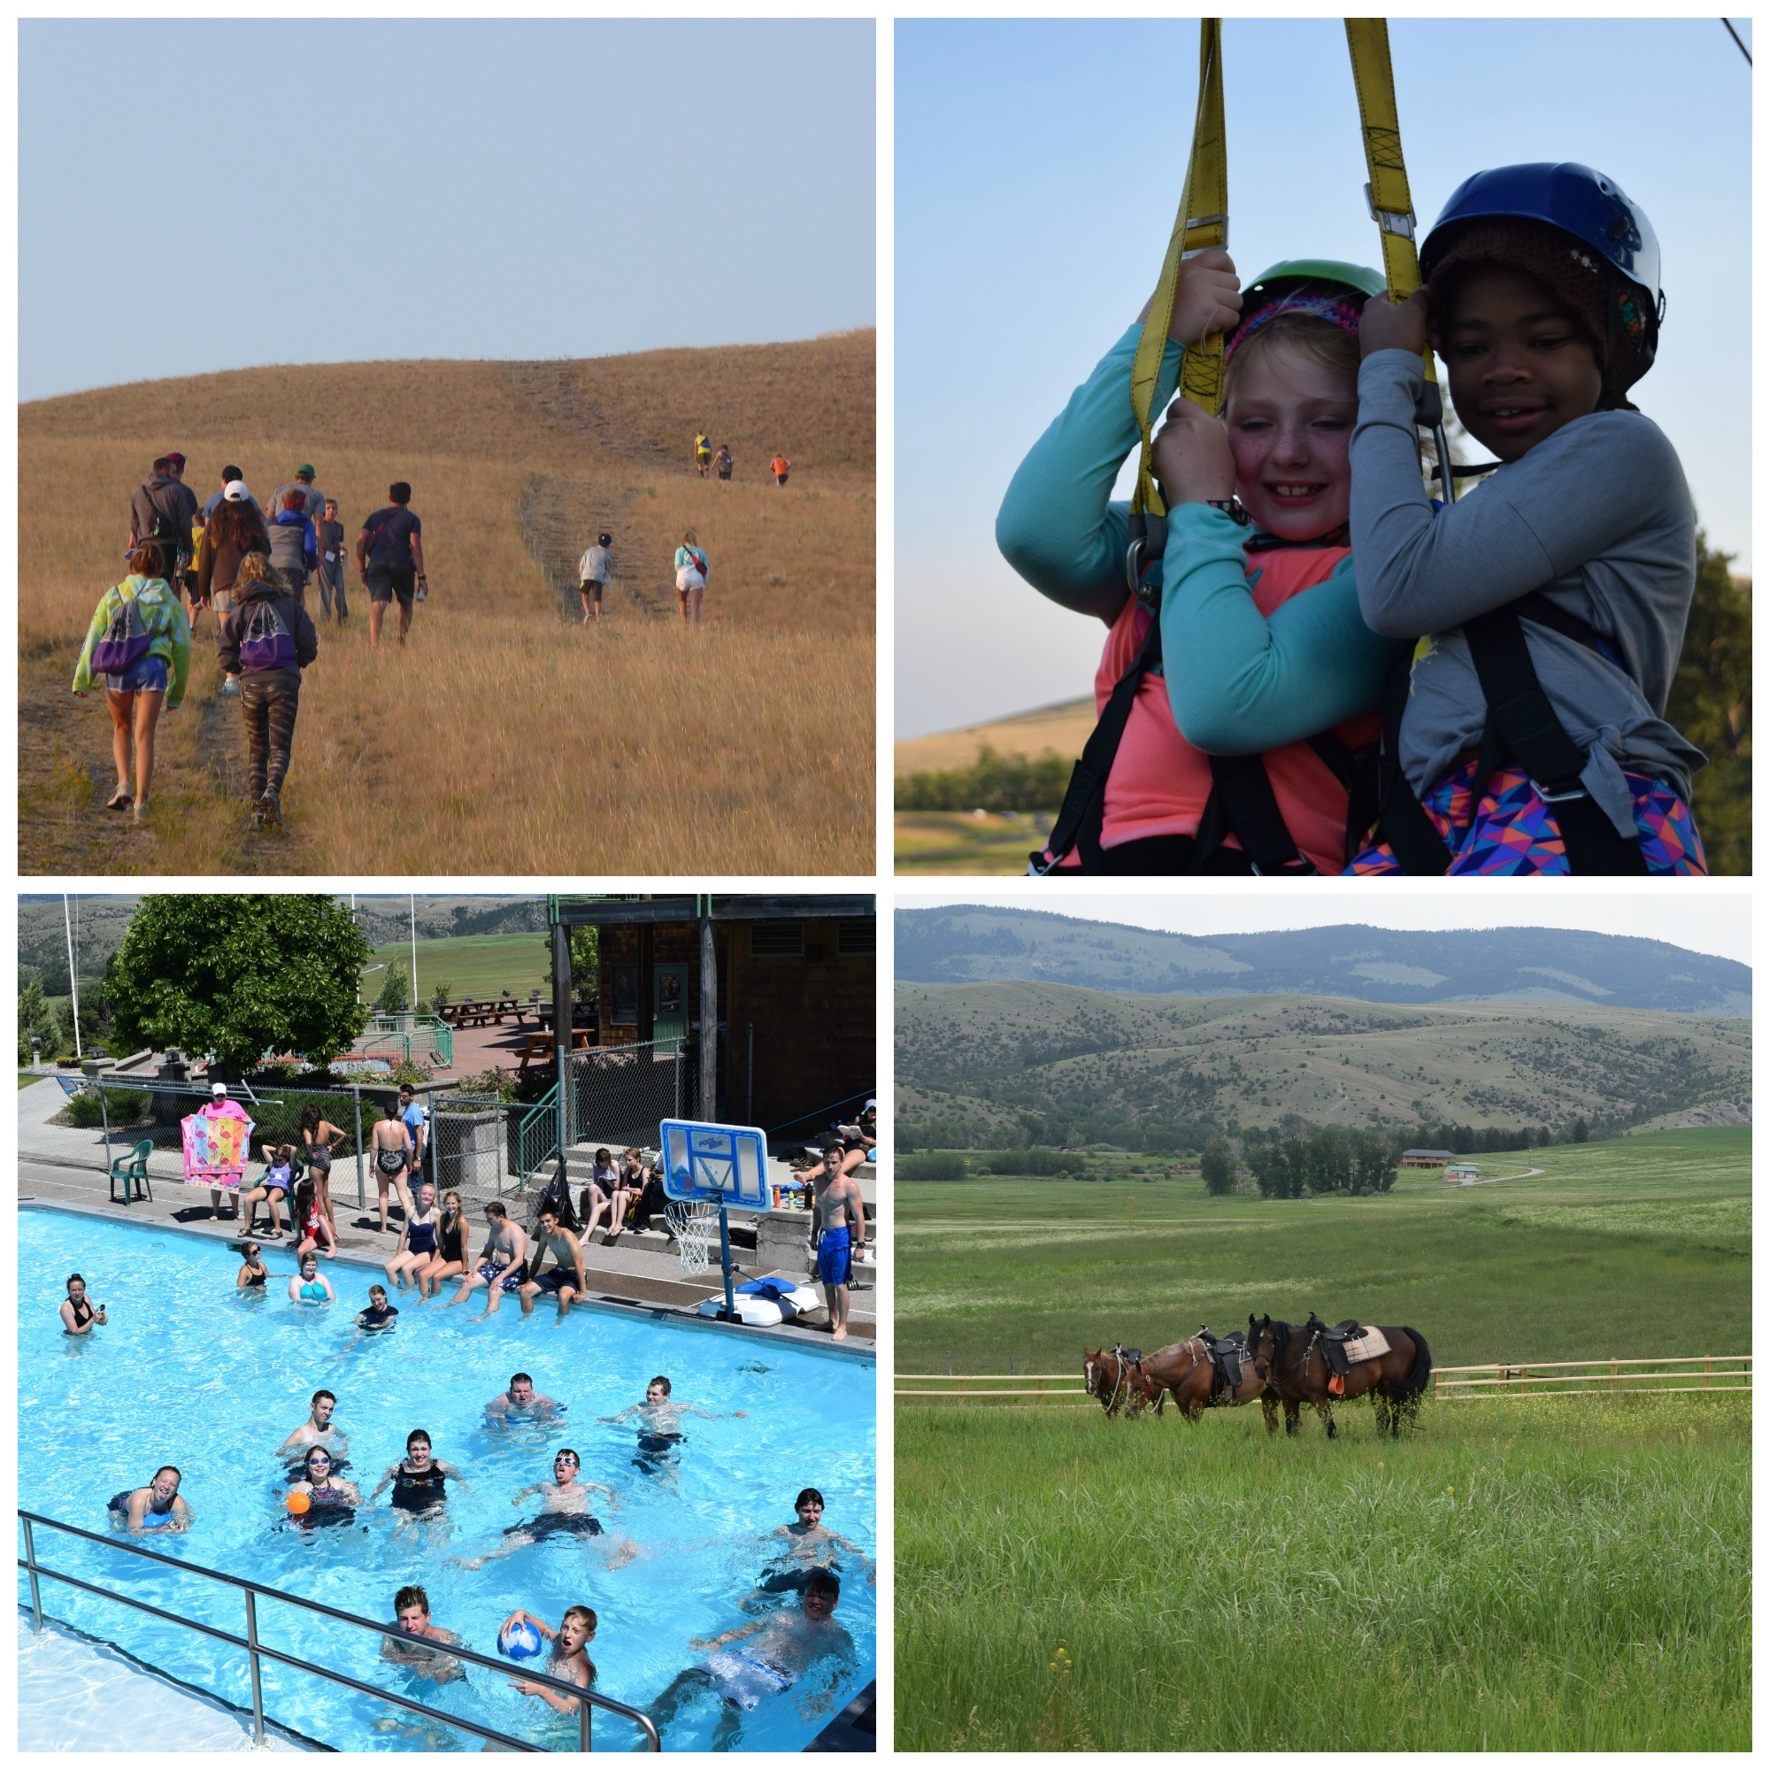

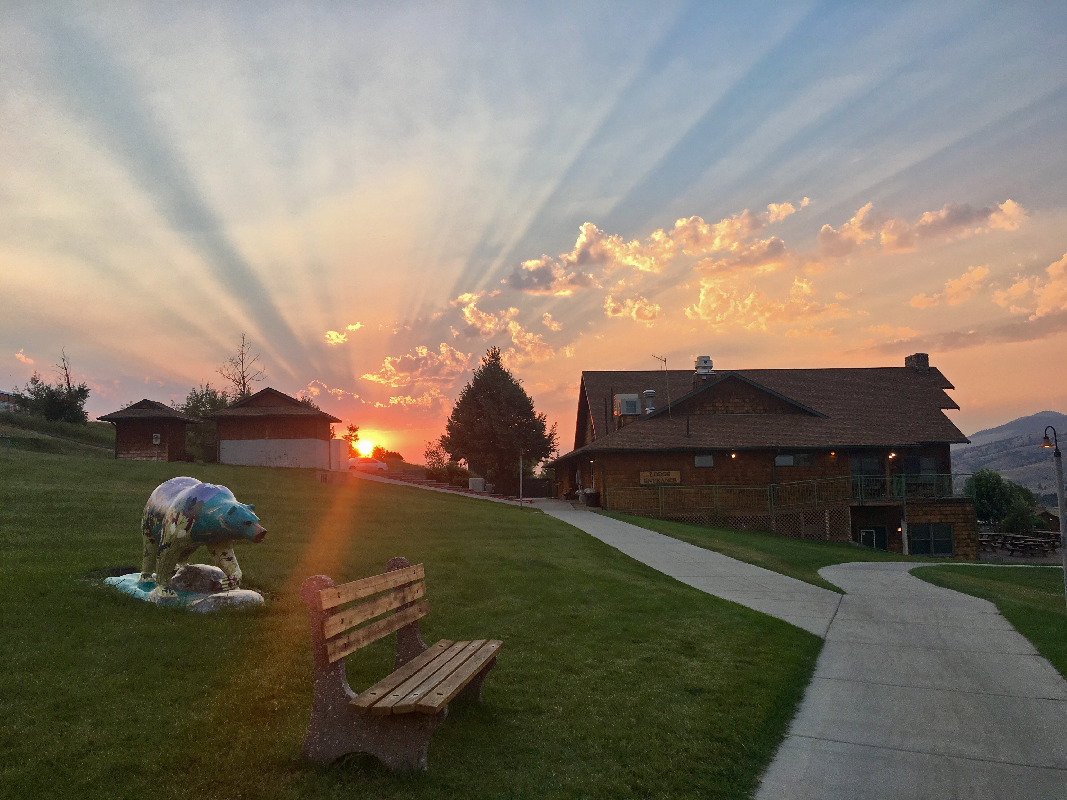

PLEASE NOTE: *Some sessions in 2022 may have slightly different criteria or be combined due to effects of the ongoing COVID-19 virus. Our primary concern is for the health and well-being of our community, so decisions will be based on the most current recommendations by the CDC, state and local government guidelines and industry best practices.