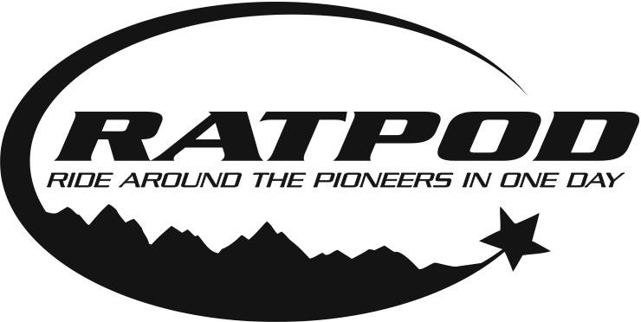

COVID-19 & What to Expect – Updated as of 6.10.21
Cancer doesn’t stop because of this crisis, and neither will we. But Camp Mak-A-Dream will implement a variety of new protocols in keeping with current guidance on event attendance from the CDC, state, city, and other local agencies to keep our participants, volunteers, staff, and host community as safe as possible.
COVID-19 has considerably affected event planning and execution details. As in-person gatherings return, Camp Mak-A-Dream is learning from industry experts and other nonprofits across the country. We are focused on following the best practices.

Overall Safety Protocols for 2021
- A rider cap of 250 will remain in place.
- The event has been reviewed through a rigorous health and safety mitigation process with multiple checks and balances to ensure the best and safest environment for participants, staff, volunteers, vendors, and sponsors.
- Personal responsibilities will be communicated to rider, staff, and volunteers prior to the event via phone, email, social media, and event website updates.
- All efforts will take place to make sure our riders, staff, and volunteers have the most up to date information available.

Event Safety Protocols
- Pre-Event COVID-19 self-screen. Please complete this self-screen prior to making your way to Dillon. If you are experiencing any COVID-19 symptoms, please refrain from attending this event.
- Based on recommendations by the local health department, face coverings will be required for all riders, volunteers, and staff throughout the event, when you are unable to maintain 6 feet of distance between you and others. Masks may be removed when on the road or while eating or drinking.
- Please practice safe social distancing practices including maintaining 6 feet of distance or more between others.
- Dedicated lanes and waiting spots will be provided to aid in physical distancing in areas where cyclists/volunteers congregate such as packet pick-up, start line, and restrooms.
- Staff and volunteers will be provided gloves or other PPE if their role requires additional interaction (ex: extra masks, disinfectant wipes, hand sanitizer, etc.).

RATPOD Unlimited Option Available
If a cyclist does not feel comfortable participating in the modified in-person experience, our RATPOD Unlimited option exists for each rider to stay connected.
RATPOD Unlimited: Registration Fee – $25

What to Expect at Packet Pick-Up
- Drive-Thru Packet Pick-up will take place Friday from 3pm-8pm in the parking lot of the Dillon Chamber of Commerce (10 W Reeder St)
- Please stay in your vehicle when picking up your packets. Our Volunteers will find your packet and hand it through your car window.
- Rider packet will include, reminder of your start time, bib, t-shirt, jersey if earned or pre-purchased.
- If you plan to pickup packets for other riders, please coordinate that with Courtney prior to arriving in Dillon.
- We will not be accepting donations during packet pickup, for any cash/check donations, please mail those directly to the Camp office by Jun 18th – Camp Mak-A-Dream, Attn: RATPOD, 2110 S. Johnson St, Missoula, MT 59801

What to Expect at the Start Lines
- All participants will receive a designated start time. You will have an opportunity to sign-up for your preferred start time beginning Thursday, June 17th. Lottery will be done based on fundraising totals as of this date (i.e., those who have raised the most as of 6.17 will be given first opportunity). Please select your first and second choice start/time.
- Consideration will be taken for teams to start together.
- Start times will be staggered with 50 riders starting at one time. Group A 6am, Group B 6:15am, Group C 6:30am, Group D 6:45am, Group E 7am.
- Staging areas will be setup on the corner of E. Cornell & Atlantic St. Riders who are in the current wave (i.e., all riders in Group A leaving at 6am) may line up behind the start/finish line on E. Cornell. Please use social distancing protocols and stay in your designated staging area until called.

What to Expect on the Routes
- Cyclists will be encouraged to follow physical distancing protocols throughout the ride.
- SAG vehicles will be available on the route with capacity limited to 50% to ensure rider and volunteer safety.
- Should you require a return trip to Dillon via bus, buses will be located at the Polaris Breakfast stop and the Wise River Lunch stop. Buses will be limited to 26 occupants for safety.
- If you are unsure as to whether you may be able to complete your ride, we encourage you to coordinate a personal SAG vehicle. Personal SAG vehicles should remain at route stops as long as possible to avoid congestion along the roadway.
- Masks will be required in all support vehicles to ensure safety.
- Cyclists must bring their own water bottles to fill at course stops.
- Masks will be required on buses.
- Self-serve bag drop will be available.

What to Expect at Course Stops
- Masks must be worn at all times by cyclists, volunteers, staff, and vendors while at stops, unless eating or drinking or able to maintain 6 feet distance.
- Masks will be on hand at stops in case a cyclist has lost their mask on the route.
- Individually packaged food/snacks/whole fruit will be available for cyclists/volunteers. At Breakfast & Lunch our volunteers on site will assist in putting your selected items into a rider bag.
  - Breakfast Menu: Breakfast sandwiches (meat & vegetarian option), fruit, nutrition bars, individually packaged hard boiled eggs.
  - Lunch Menu: Wraps, individual bags of chips, fruit, individually packaged hard boiled eggs.
- Individual packets of sports drink at the hydration area to mix into your water bottles.
- Portable toilets will be provided with hand sanitizer stations.
- All cyclists will be required to dispose of their own recycling and trash in designated bins.
- Participants should sit only with those whom they have had close contact with.

What to Expect at the Finish Line
- Post-Ride festivities will take place at the UM Western Campus and setup to ensure social-distancing protocols.
- Beer garden will be set-up for social distancing protocols, staffed by volunteers.
- Post-ride meal will be served by UM Campus staff.
- Please sit & eat only with the RATPOD group you have arrived with and follow social distancing protocols.
- Masks will be available in case cyclist lost their mask on the route.
- All cyclists will be required to dispose of their own recycling and trash in designated bins.
We look forward to working with our riders, our staff, and our volunteers to provide a safe event for all.

