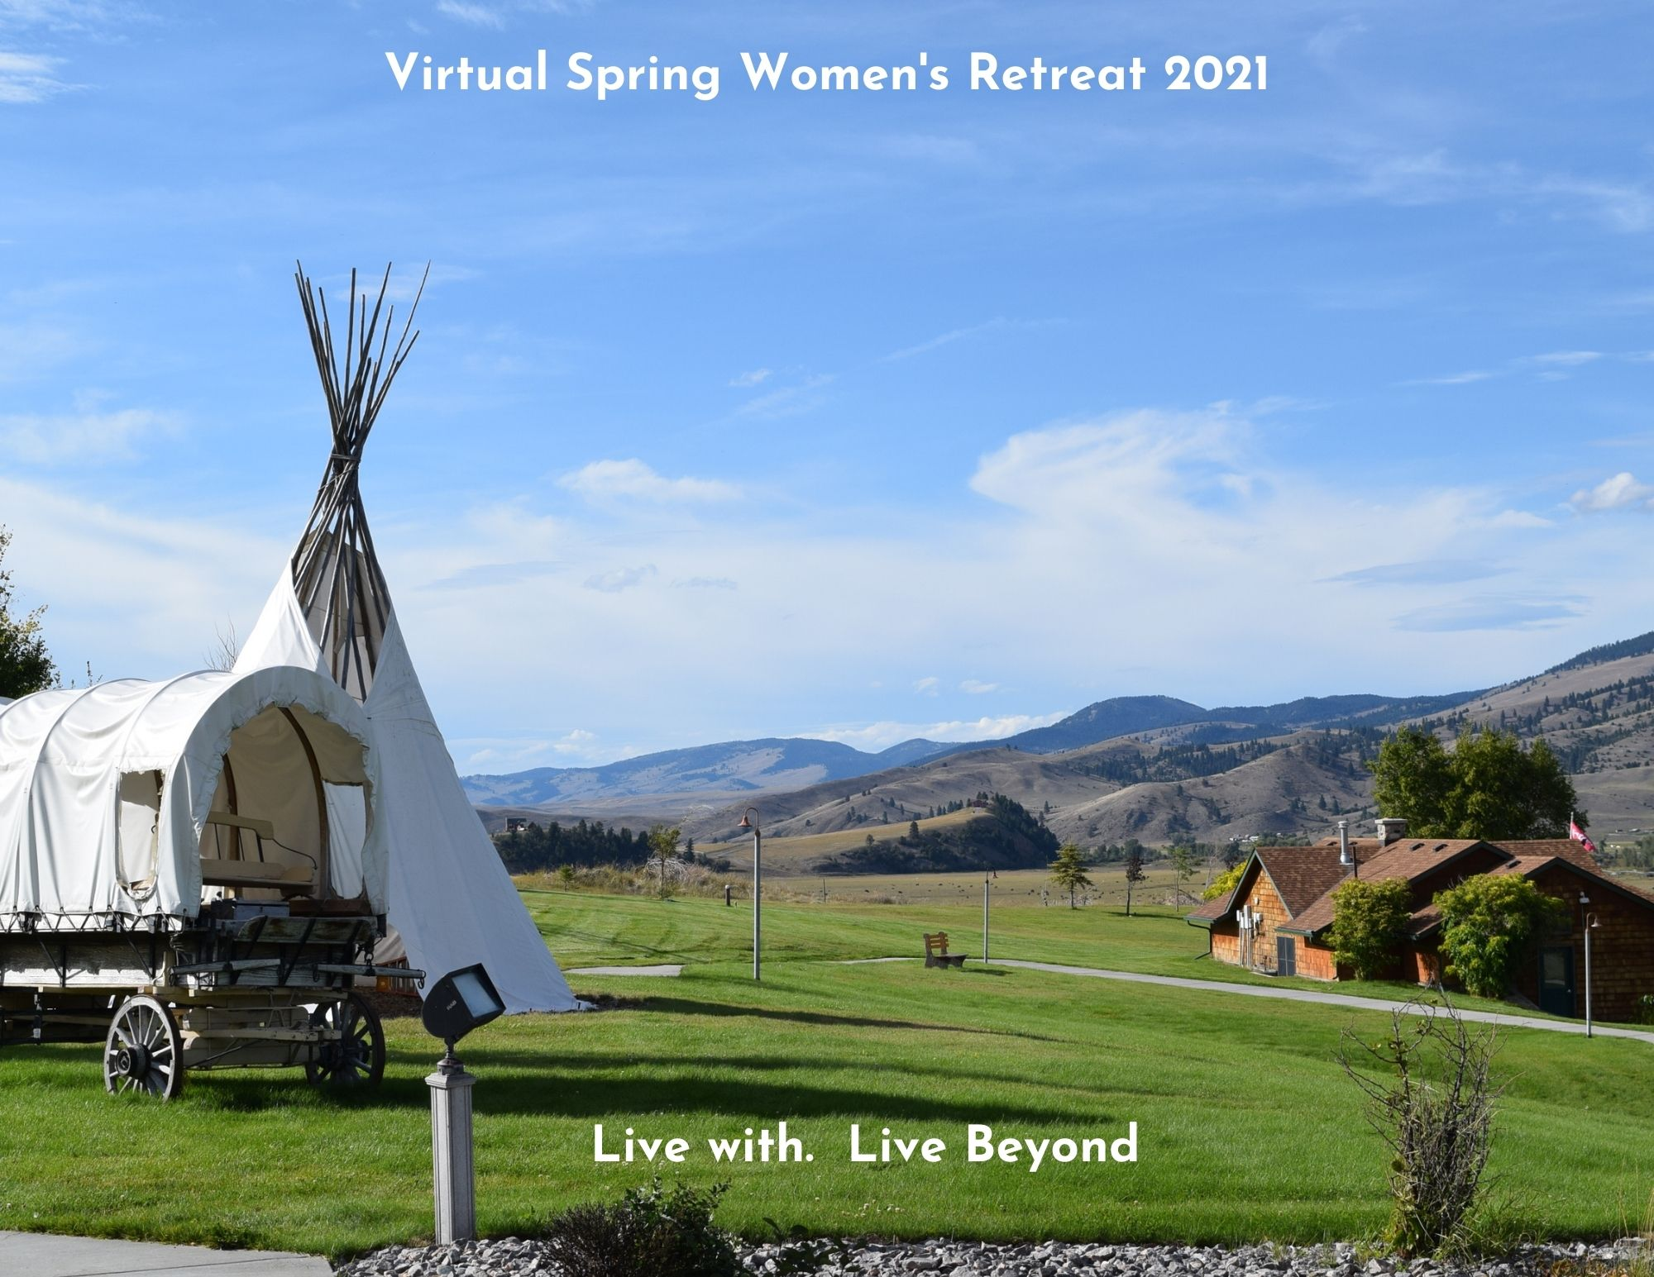
Welcome to the Virtual Spring Women’s Cancer Retreat 2021 – Take 2!
Below is the schedule for the week and some tips for attending virtual camp! All time zones are listed below, be sure that you are signing in according to your time zone. Please click on the link (Ctrl + Click) 5-10 minutes before the start of a session so that we can let you in from the Zoom waiting room.
- Sessions with an (*) have a description and/or supply list below the schedule
- During the first ‘Break’ there are some ‘on your own’ options for you to enjoy a little bit of Montana, all other sessions are interactive
- Attend as many or as few sessions as you like; we will do our best to allow for at least 10 minutes between sessions
- Have fun…we are glad you are here!

Time (ET) | Time (CT) | Time (MT) | Time (PT) | Thursday, May 20 | Friday, May 21 | Saturday, May 22
12:00 | 11:00 | 10:00 | 9:00 |  | Yoga/Movement*  Presenters: Katie Thompson  Click here to join | TBD: Genetics info*  Presenter:Michelle Weaver Knowles  Click here to join
1:30 | 12:30 | 11:30 | 10:30 |  | Cooking class – Ravioli*  Presenter: Chef Joe  Click here to join | The Superpower of Sleep/Rest *  Presenter: Tessa, Camp Staff Click here to join
3:00 | 2:00 | 1:00 | 12:00 |  | Celebration of Life* Click here to join | On your own: Lance slideshows  Video link
4:00 | 3:00 | 2:00 | 1:00 | Welcome & Icebreakers  Presenters: Camp Staff  Click here to join | Topic: Finding your Strengths*  Presenter: Clare Janty  Click here to join | Art: Create your own photo frame*  Presenter: Jen  Click here to join
5:30 | 4:30 | 3:30 | 2:30 | Contact with the Present Moment*  Presenter: Tessa  Click here to join | Art: Bath Bombs & Body Scrub*  Presenter: Jen  Click here to join | Final Fireside Chat*  Presenter: Tessa  Click here to join
6:45 | 5:45 | 4:45 | 3:45 | Fun & Games (Get to Know You Scavenger Hunt)  Presenters: Camp Staff  Click here to join | Fun & Games (Logo Jeopardy)  Presenters: Camp Staff  Click here to join | Closing, Talent & Art Show  Presenter: Camp Staff  Click here to join
8:00 | 7:00 | 6:00 | 5:00 | Fireside Chat*  Presenter: Tessa  Click here to join | Fireside Chat *  Presenter: Tessa  Click here to join | After Camp Social Hour  Hosted by you!  Click here to join

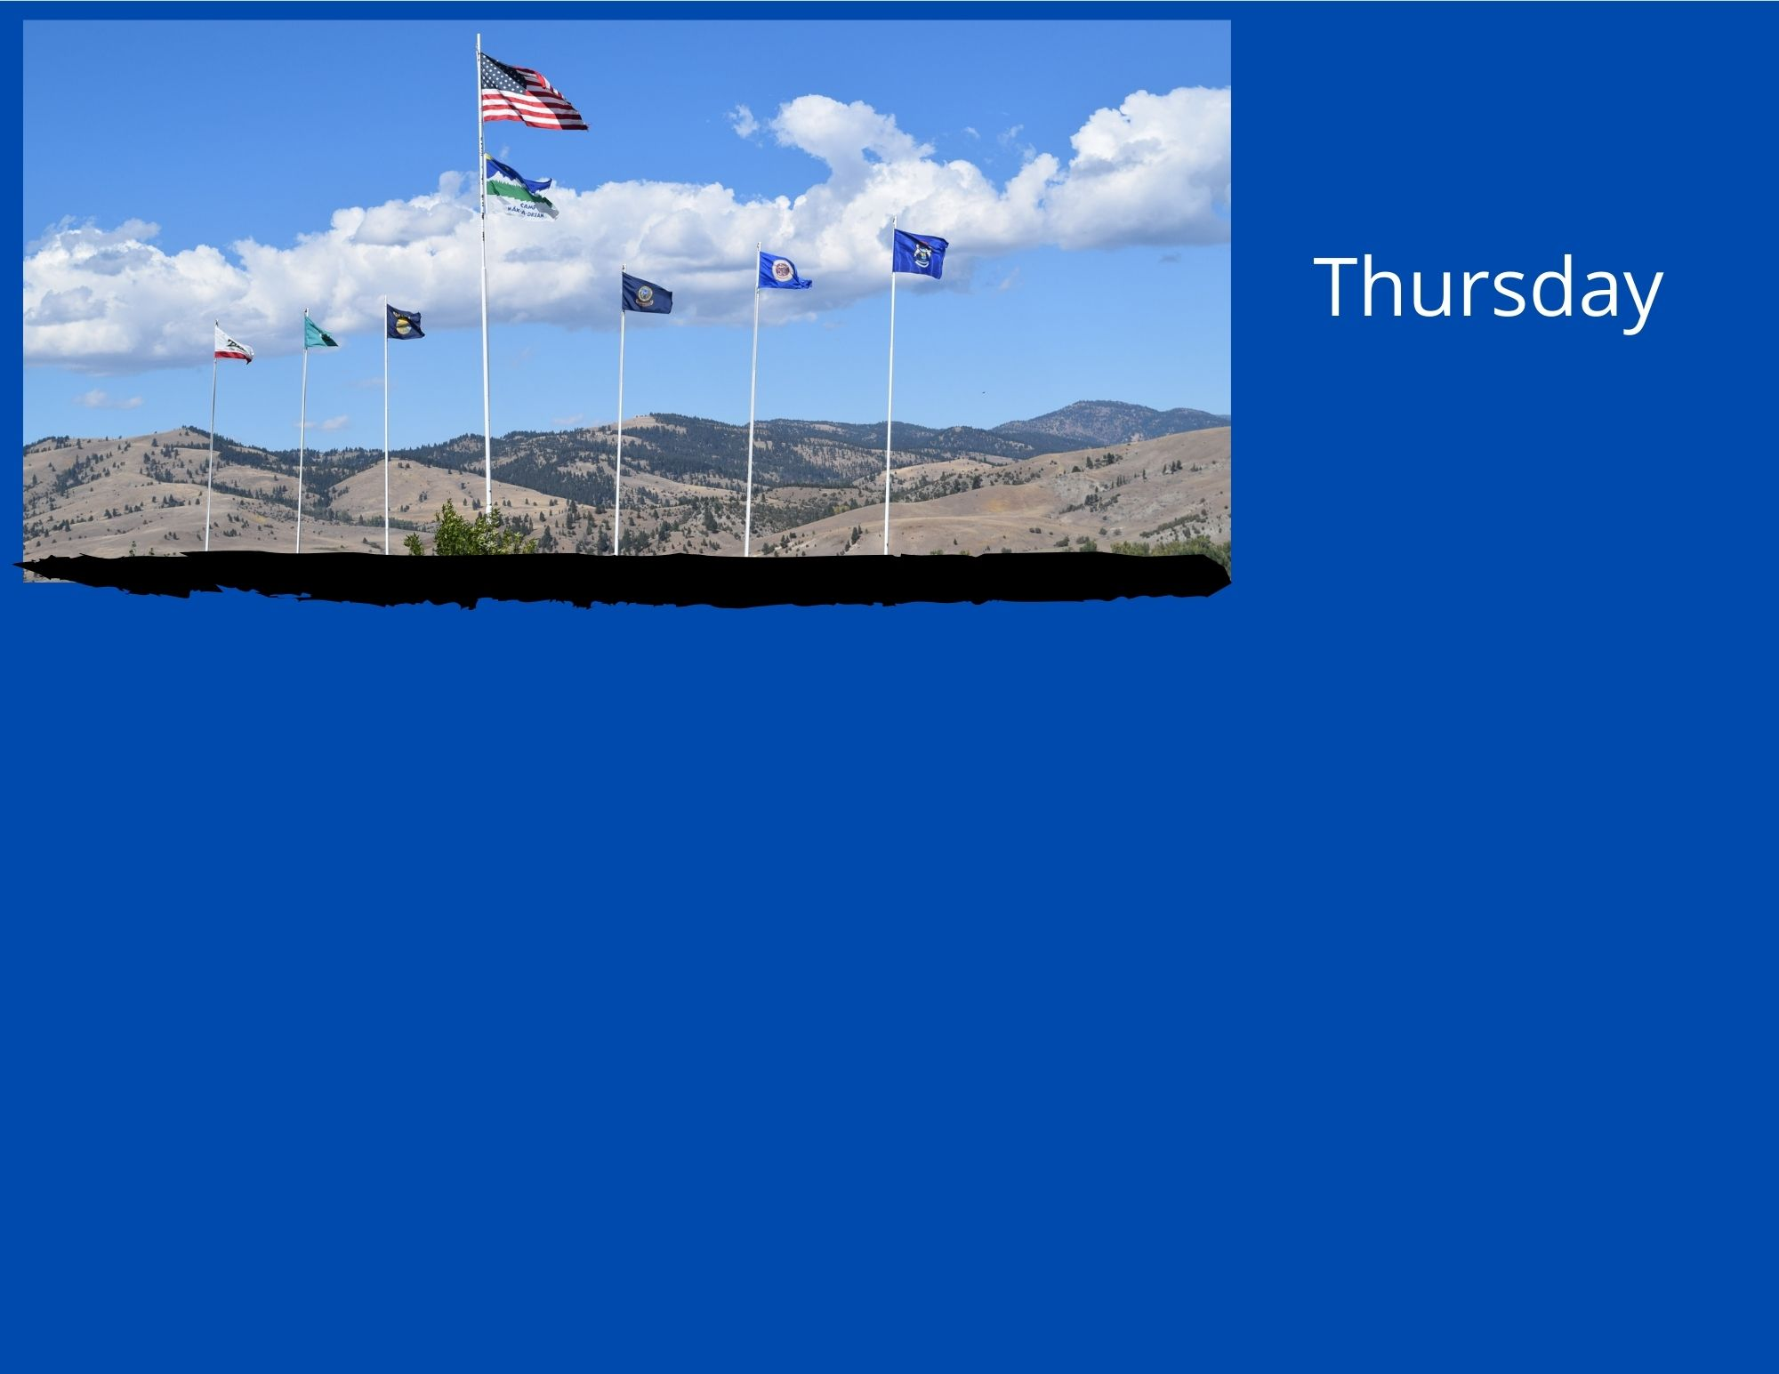

May 20

Contact with the Present Moment - Tessa
This workshop will focus on a few techniques for improving emotional and mental wellness. Being able to make contact with the present moment is a useful skill for managing down-ward spiraling emotions, feeling overwhelmed with emotion, panic attacks or high anxiety episodes, and gaining more control (in general) over emotions and thoughts. Participants will have the opportunity to learn and practice these techniques in a safe, supportive environment.

Fireside Chat – Tessa
Fireside Chat is an optional, informal discussion session held each evening during this retreat. Get to know others and talk about what is on your mind. The discussion will go in whatever direction the group wants it to go!
Tessa Heuermann, LCSW, Wellness Programming Manager with Camp Mak-A-Dream
Tessa has facilitated workshops and trainings throughout her career as a Social Worker. Prior to working at Camp Mak-A-Dream, Tessa provided clinical mental health care in a medical clinic, including care to those facing chronic and terminal illness. Her favorite work includes using Acceptance and Commitment Therapy (ACT) concepts to help others function better and enjoy life more. In addition to ACT, Tessa has been trained in Trauma-Sensitive Mindfulness, Problem Solving Treatment, and Integrated Behavioral Health Care.

Workshop - Presenter
DESCRIPTION

SUPPLIES:

Workshop - Presenter
DESCRIPTION

SUPPLIES:

Workshop - Presenter
DESCRIPTION

SUPPLIES:

Workshop - Presenter
DESCRIPTION

SUPPLIES:
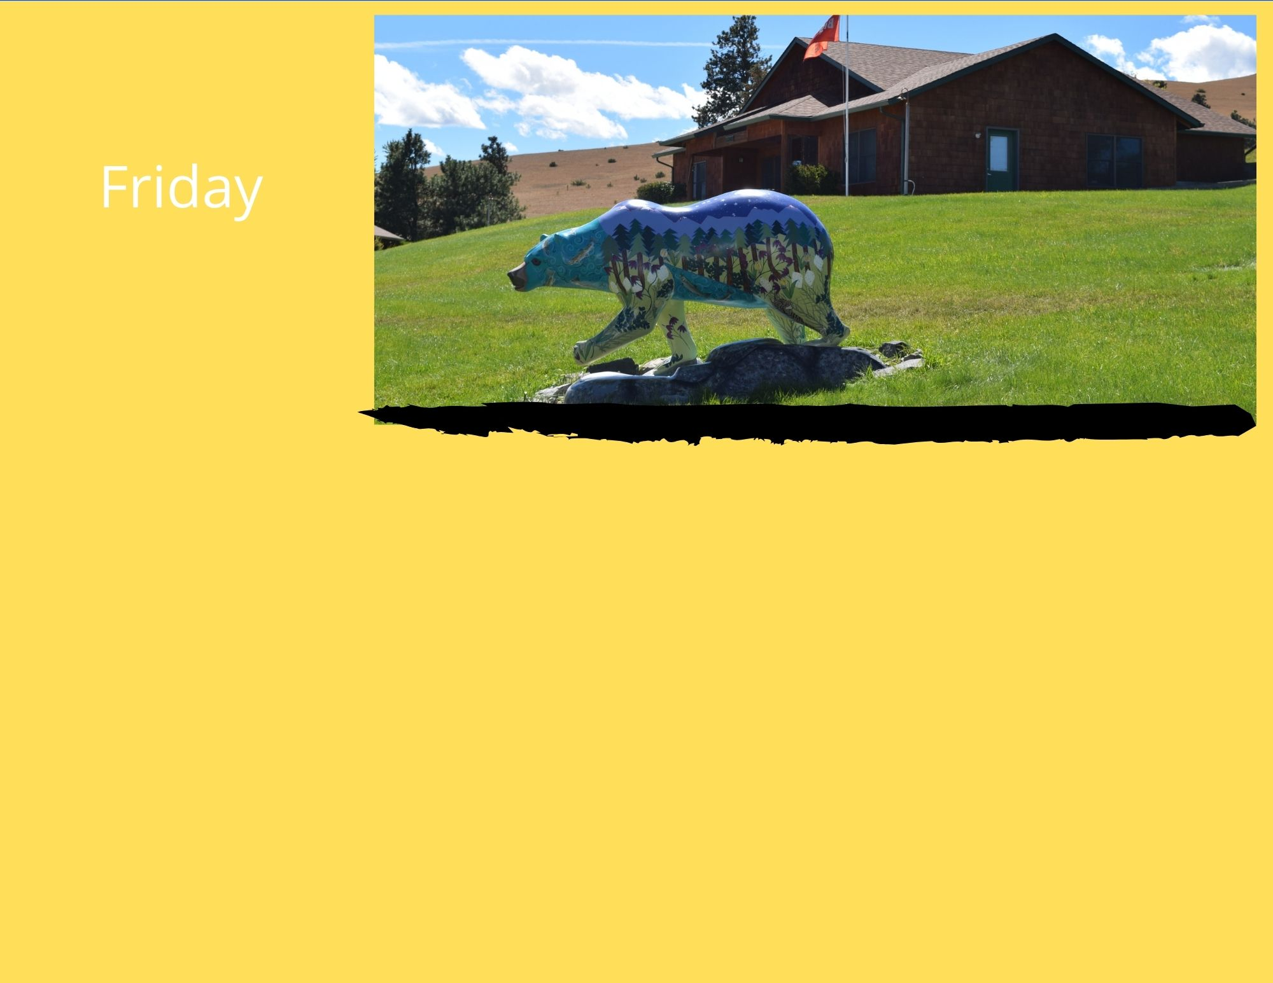

May 21

Authentic Movement - Katie
DESCRIPTION

SUPPLIES:

Homemade Pasta– Chef Joe
DESCRIPTION

SUPPLIES:

Optional: Celebration of Life – Camp Staff
This will be a time to pay tribute to the women who have attended the women’s cancer retreat in the past and whom we have lost within the last year. It is a time to reflect, share memories and honor these women. It is also a time when you can share about other losses in your life, of those who may not have any history with Camp. Everyone is welcome.

Building Your Personal Power – Clare Janty
In this session, Clare Janty Master Certified Life Coach, will lead the exploration of your personal power focusing on your strengths and authenticity. How did your strengths assist in your coping with COVID? Is there a strength you wish to develop? The interactive discussion will result in participants creating their personal action plan for moving forward.
Clare Janty
Clare Janty is a semi-retired Physician Assistant and Master Certified Life Coach. She has presented at Camp Mak_A_Dream to different age audiences since 2007. Currently she is coaching community college students, frontline health care workers and breast cancer survivors. During COVID she has done many creative art projects as well as being active outdoors.

Self-Care Art: Bath Bombs & Body Scrub - Jen
What can be better than easy art projects that also help with your future self-care?!? Join us in making bath bombs and a gingerbread body scrub.

SUPPLIES:
Bath Bombs: Epsom salt, Baking soda, Lemon juice, ice cube tray/muffin tin/other mold
Optional: Food coloring, Essential oil or fragrance
Body Scrub: Brown sugar, Coconut oil (solid), molasses, ground ginger, ground cloves, ground cinnamon

Fireside Chat – Tessa
Fireside Chat is an optional, informal discussion session held each evening during this retreat. Get to know others and talk about what is on your mind. The discussion will go in whatever direction the group wants it to go!

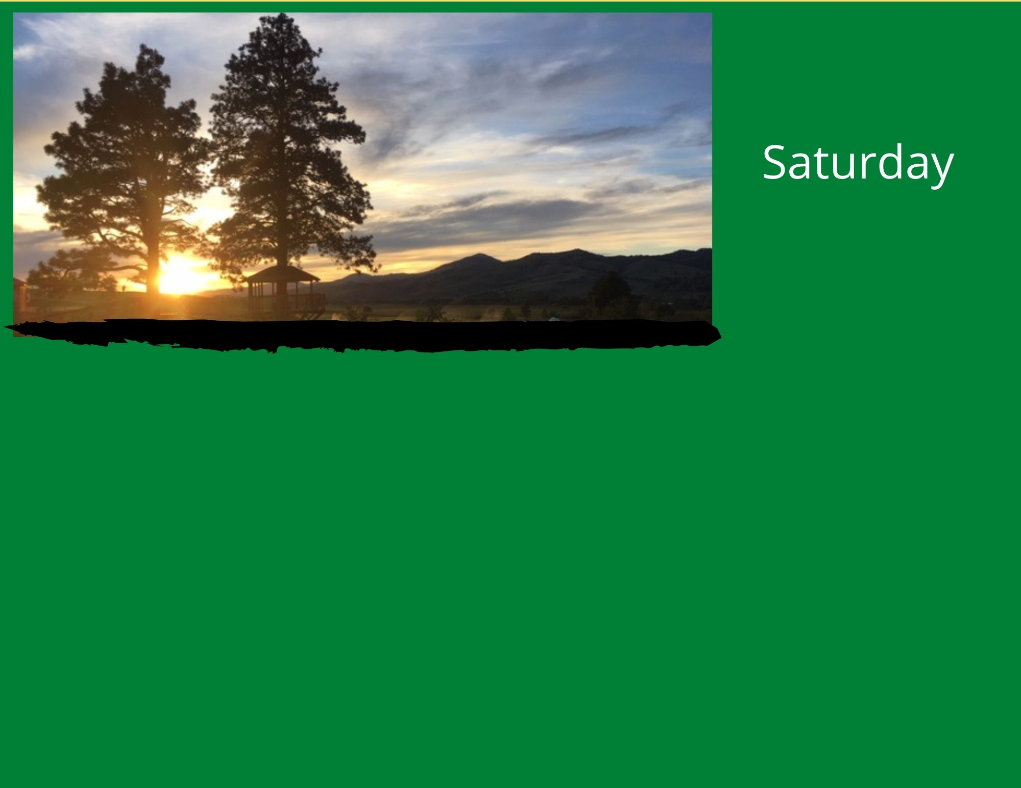

May 22

Genetics – Michelle Weaver Knowles
DESCRIPTION

SUPPLIES:

The Superpower of Sleep/Rest - Tessa
If you could choose your own “superpower,” would you pick “sleep?” Sleep and rest have the power to improve wellness on EVERY level! Participants will learn about the negative impacts of sleep deprivation, healthy sleep “hygiene” and the value in prioritizing sleep and rest in their daily lives. Full of evidence-based information, this workshop will lead participants to develop a “sleep plan” they can implement and even share with others in their household, in order to support their own wellness.

SUPPLIES: Pen or Pencil, Paper

On your own: Montana Slideshow - Lance Schelvan
DESCRIPTION

SUPPLIES:

Making your Own Photo Frame- Jen
DESCRIPTION

SUPPLIES:

Final Fireside Chat – Tessa
Fireside Chat is an optional, informal discussion session held each evening during this retreat. Get to know others and talk about what is on your mind. The discussion will go in whatever direction the group wants it to go!

Closing and Talent & Art Show – Camp Staff
We hope you will join us to wrap up our time together. We will take the opportunity to say “Until next time…” and to watch a video showcasing the Talents and Art of your fellow participants. Upon the conclusion, Camp Staff will step away and turn things over to the group for a Social Hour (using the same link).

Thank you for joining us!!
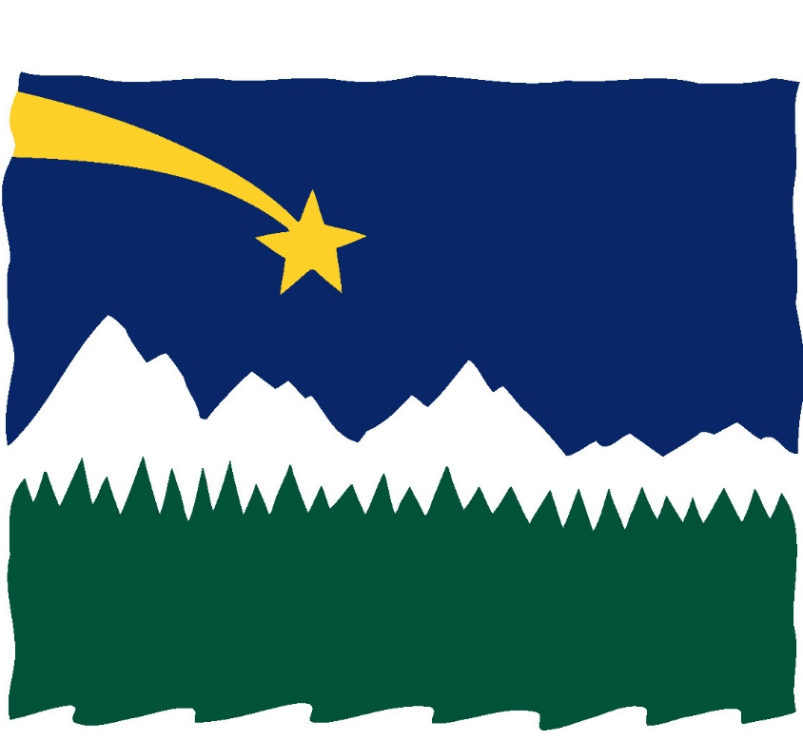
Other links you may want quick access to:
Talent & Art Show Dropbox submission: https://www.dropbox.com/request/natcLo4yJCx6LbFz8qRp
Warm fuzzy message submission: jen@campdream.org
Closed “Secret” Camp Website:
Camp’s Youtube channel: https://www.youtube.com/channel/UCk2DL0-fqsuIE-vs6KGbOFA

Thank you to all of our special guests and presenters –
Katie, Clare, and Michelle!
Thank you Lance for providing our bonus video content!

Camp Mak-A-Dream Staff
Linda Baldwin – Business Operations Jen Emendorfer-Wade – Camper Manager
Jennifer Benton – Program Director Tessa Heuermann – Wellness Programming Manger
Joe Colistro – Chef Kim McKearnan – Executive Director
Maria Davis Thrasher – Bookkeeper/Bus. Operations Jake Wood – Facilities Director

Ways you can support Camp Mak-A-Dream:
Follow us on social media, make a contribution, visit our website about upcoming events.

