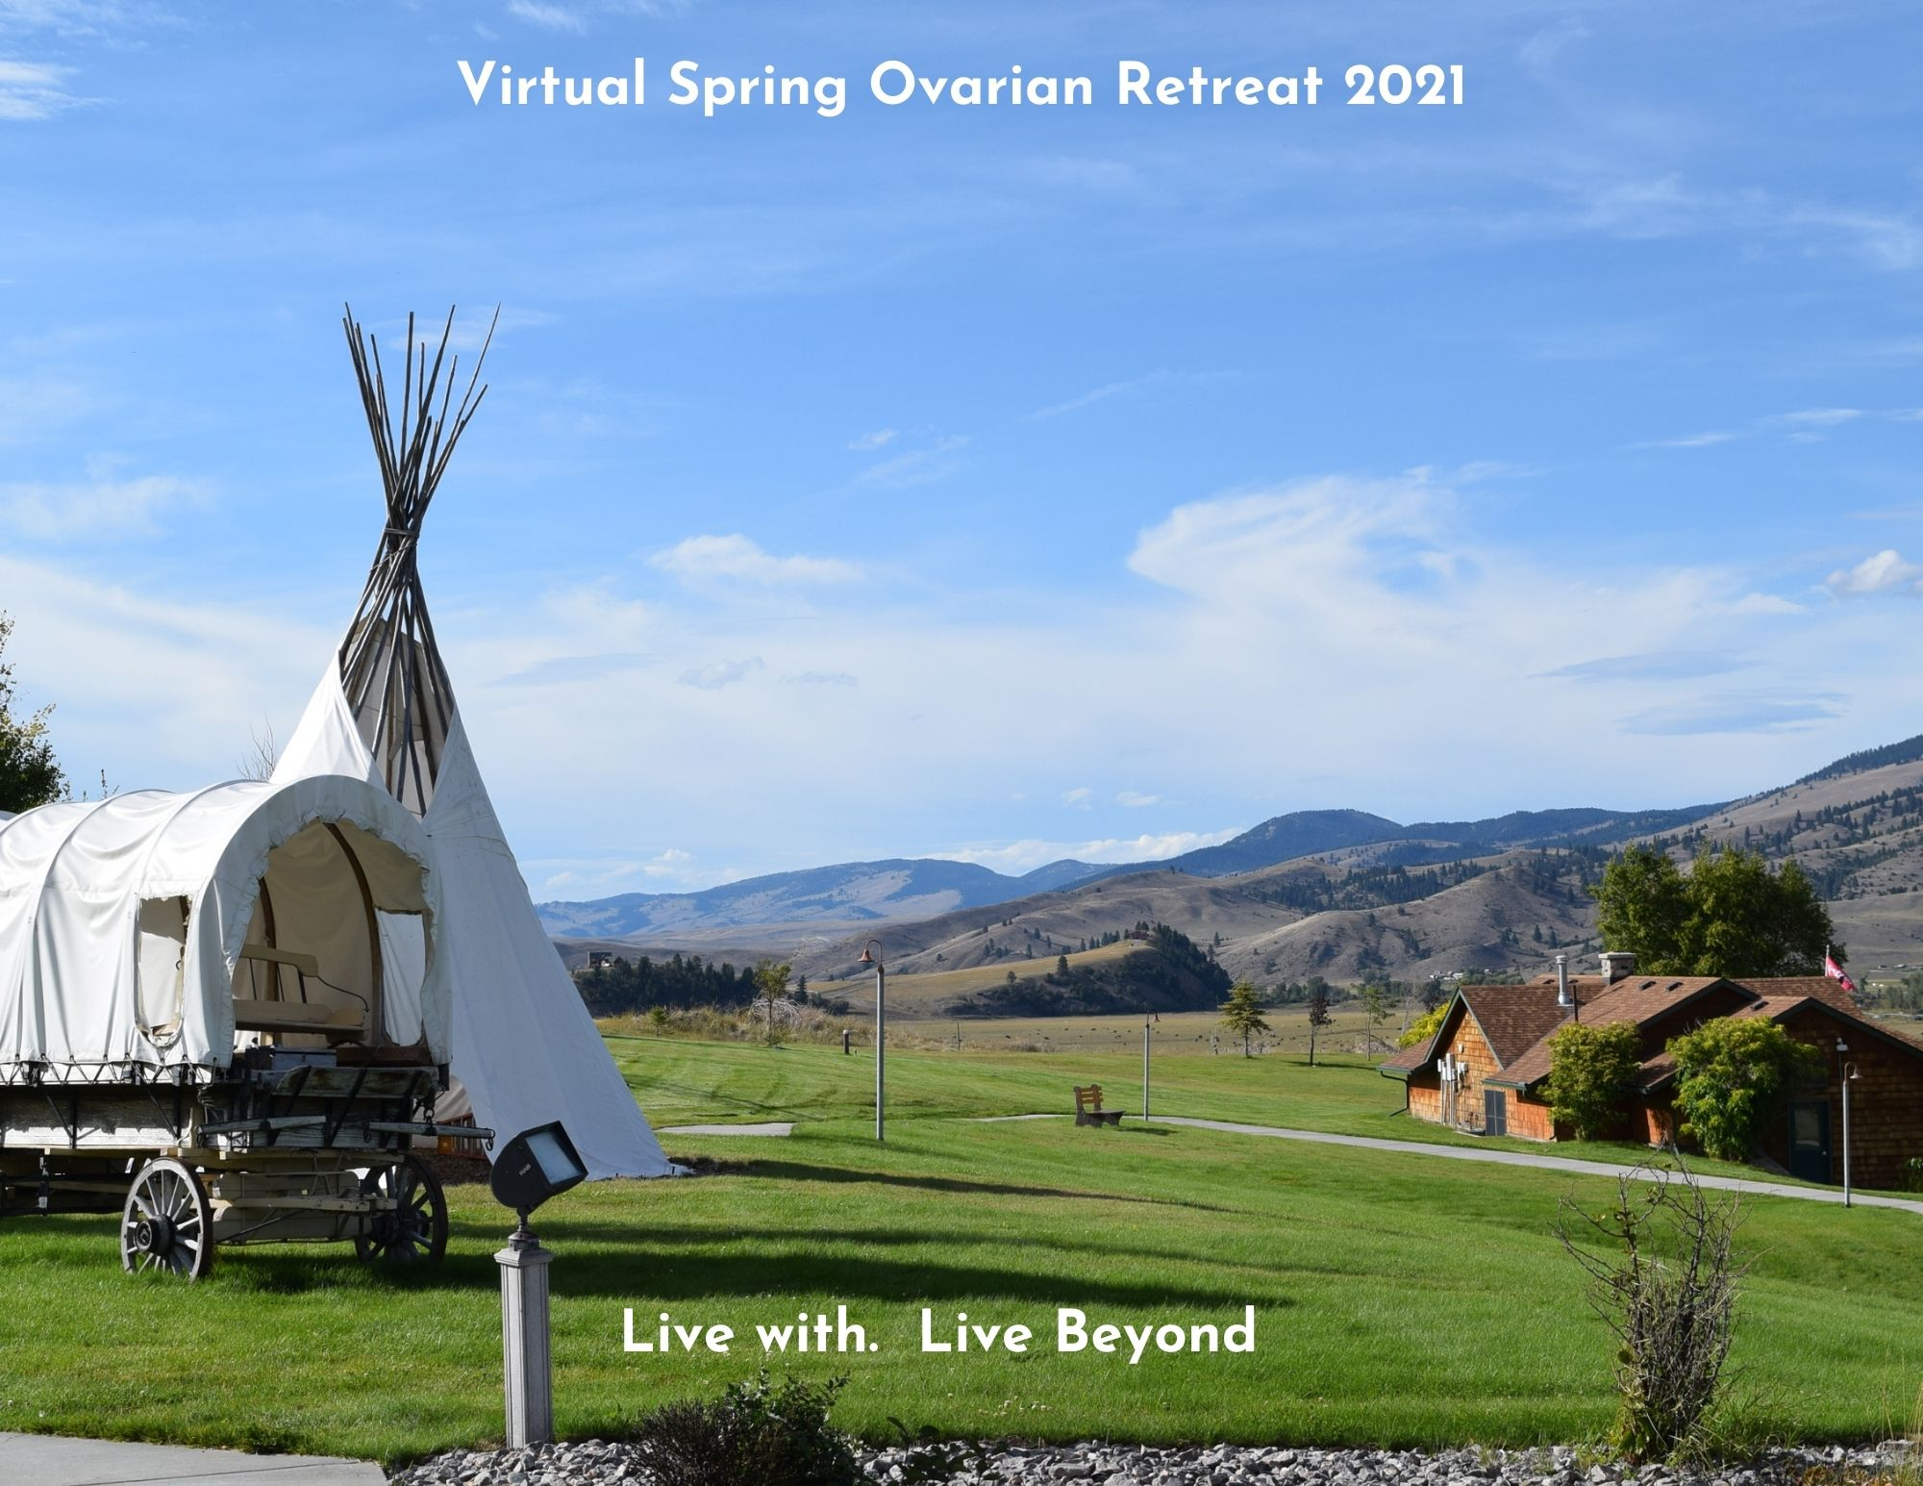
Welcome to the Virtual Spring Ovarian Cancer Retreat 2021 – Take 2!
Below is the schedule for the week and some tips for attending virtual camp! All time zones are listed below, be sure that you are signing in according to your time zone. Please click on the link (Ctrl + Click) 5-10 minutes before the start of a session so that we can let you in from the Zoom waiting room.
- Sessions with an (*) have a description and/or supply list below the schedule
- During the first ‘Break’ there are some ‘on your own’ options for you to enjoy a little bit of Montana, all other sessions are interactive
- Attend as many or as few sessions as you like; we will do our best to allow for at least 10 minutes between sessions
- Have fun…we are glad you are here!

Time (ET) | Time (CT) | Time (MT) | Time (PT) | Thursday, May 13 | Friday, May 14 | Saturday, May 15
12:00 | 11:00 | 10:00 | 9:00 |  | Mindful Movement*  Presenters: Sondra Albert  Click here to join | Art/Poetry: Seventeen Syllables*  Presenter: Molly Stockdale  Click here to join
1:30 | 12:30 | 11:30 | 10:30 |  | Cooking class – Ravioli*  Presenter: Chef Joe  Click here to join | The Superpower of Sleep/Rest*  Presenter: Tessa  Click here to join
3:00 | 2:00 | 1:00 | 12:00 |  | Celebration of Life*  Click here to join | On your own: Montana slideshows  Video link 1 Video link 2  Video link 3
4:00 | 3:00 | 2:00 | 1:00 | Welcome & Icebreakers  Presenters: Camp Staff  Click here to join | Finding your Strengths*  Presenter: Clare Janty  Click here to join | Connecting with and Expressing What’s Alive in Us*  Presenter: Patrick Marsolek  Click here to join
5:30 | 4:30 | 3:30 | 2:30 | Contact with the Present  Moment*  Presenter: Tessa  Click here to join | Art: Bath Bombs & Body Scrub *  Presenter: Jen  Click here to join | Final Fireside Chat  Presenters: Vivien & Tessa  Click here to join
6:45 | 5:45 | 4:45 | 3:45 | Fun & Games (Get to Know You Scavenger Hunt)  Presenters: Camp Staff  Click here to join | Fun & Games (Logo Jeopardy)  Presenters: Camp Staff  Click here to join | Closing, Talent & Art Show  Presenter: Camp Staff  Click here to join
8:00 | 7:00 | 6:00 | 5:00 | Fireside Chat*  Presenters: Vivien & Tessa Click here to join | Fireside Chat*  Presenters: Vivien & Tessa Click here to join | After Camp Social Hour  Hosted by you!  Click here to join

May 13

Contact with the Present Moment - Tessa
This workshop will focus on a few techniques for improving emotional and mental wellness. Being able to make contact with the present moment is a useful skill for managing down-ward spiraling emotions, feeling overwhelmed with emotion, panic attacks or high anxiety episodes, and gaining more control (in general) over emotions and thoughts. Participants will have the opportunity to learn and practice these techniques in a safe, supportive environment.

Fireside Chat – Vivien & Tessa
Fireside Chat is an optional, informal discussion session held each evening during this retreat. Get to know others and talk about what is on your mind. The discussion will go in whatever direction the group wants it to go!

Vivien Weiss, LMHC
Vivien is a psychotherapist living in Northampton, Massachusetts and has been in private practice for over 35 years. She specializes in working with people struggling with the challenges of having cancer. In addition, she deals with those who are grieving the loss of a loved one. She facilitates support groups for women with gynecological cancers for Cancer Connection, a small nonprofit in her hometown. She has been volunteering at Camp Mak-A-Dream since 2005. In addition to camp, she is most passionate about the theater and frequents Broadway on a regular basis. She also loves spending time with her three grandsons!

Tessa Heuermann, LCSW, Wellness Programming Manager with Camp Mak-A-Dream
Tessa has facilitated workshops and trainings throughout her career as a Social Worker. Prior to working at Camp Mak-A-Dream, Tessa provided clinical mental health care in a medical clinic, including care to those facing chronic and terminal illness. Her favorite work includes using Acceptance and Commitment Therapy (ACT) concepts to help others function better and enjoy life more. In addition to ACT, Tessa has been trained in Trauma-Sensitive Mindfulness, Problem Solving Treatment, and Integrated Behavioral Health Care.
Workshop - Presenter
DESCRIPTION

SUPPLIES:

Workshop - Presenter
DESCRIPTION

SUPPLIES:

Workshop - Presenter
DESCRIPTION

SUPPLIES:

Workshop - Presenter
DESCRIPTION

SUPPLIES:
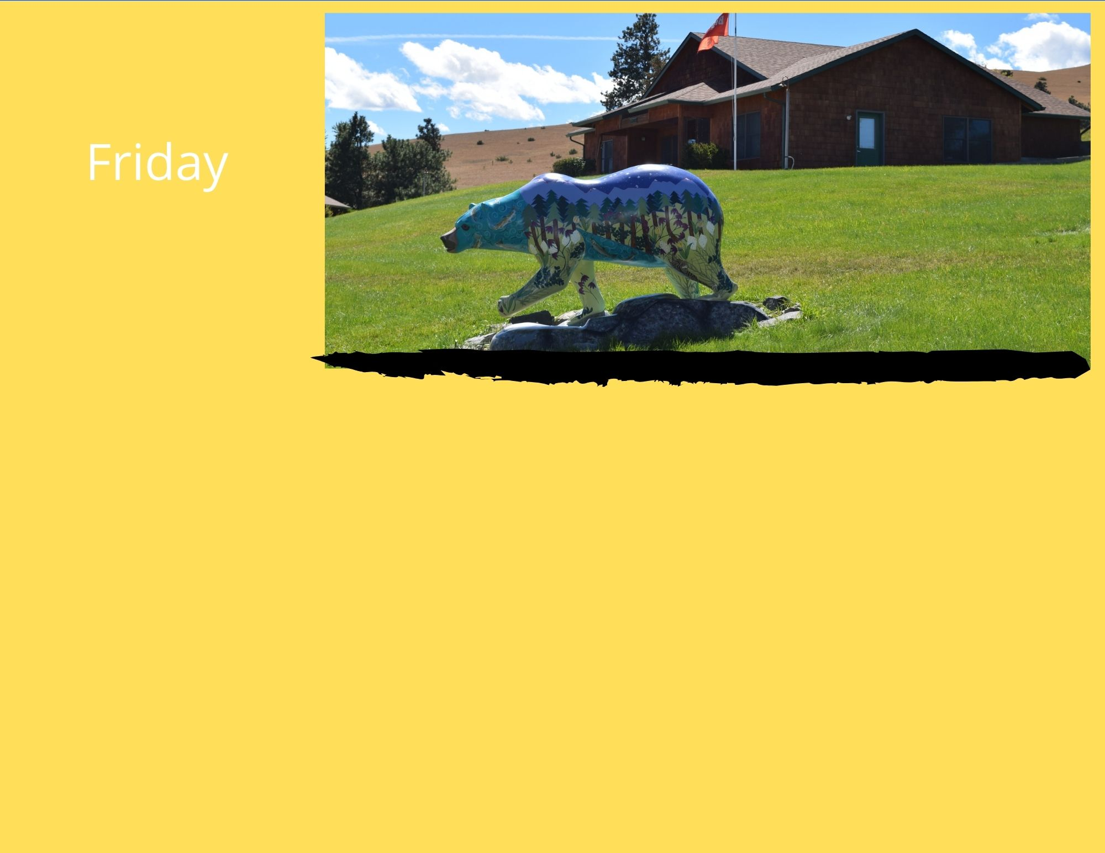

May 14

Mindful Movement– Sondra Albert
Mindful movement is a multi-faceted practice that coordinates movement and breath. This practice helps to relax the body and reduce the mind’s constant chatter. It also helps us concentrate on living in the present and focus on what is most important in our lives. We will do a series of gentle yoga poses with a focus on our breath as we move. There will be many options offered so this class is for everyone.

SUPPLIES: Please come with a yoga mat and a blanket. (If you don’t have a mat, a towel on the floor works too. If balance is a challenge, please also bring a chair.

Homemade Pasta– Chef Joe
Camp’s own Chef Joe grew up in a big Italian family where pasta was a mainstay. Joe has published a cook book featuring some of those family classic recipes, as well as many of his own creations. In this workshop, Chef Joe will walk you through making one of his favorites….ravioli. You can either simply watch his live demonstration and use his recipe to make your own masterpiece in the future, OR, you can make this dish live along with him during this session. If you’d like to take part and cook along today, there are a few things you will need to do ahead of time to be ready. First, watch Joe’s video on making the actual pasta (which should be done a day or two in advance and refrigerated), and next, look through your pantry or make a quick trip to the market to get the ravioli filling ingredients of your choosing. Here is the PASTA recipe to make ahead, and the RAVIOLI ingredients, filling and tools list you will need. Then watch the PASTA demo video. This dish will not disappoint….and neither will Joe’s humor as he leads you on this culinary adventure!
SUPPLIES: Please refer to the emailed attachments for the needed ingredients

Optional: Celebration of Life – Camp Staff
This will be a time to pay tribute to the women who have attended the ovarian cancer retreat in the past and whom we have lost within the last year. It is a time to reflect, share memories and honor these women. It is also a time when you can share about other losses in your life, of those who may not have any history with Camp. Everyone is welcome.

Building Your Personal Power – Clare Janty
In this session, Clare Janty Master Certified Life Coach, will lead the exploration of your personal power focusing on your strengths and authenticity. How did your strengths assist in your coping with COVID? Is there a strength you wish to develop? The interactive discussion will result in participants creating their personal action plan for moving forward.
Clare Janty
Clare Janty is a semi-retired Physician Assistant and Master Certified Life Coach. She has presented at Camp Mak-A-Dream to different age audiences since 2007. Currently she is coaching community college students, frontline health care workers and breast cancer survivors. During COVID she has done many creative art projects as well as being active outdoors.

Self-Care Art: Bath Bombs & Body Scrub - Jen
What can be better than easy art projects that also help with your future self-care?!? Join us in making bath bombs and a gingerbread body scrub.

SUPPLIES:
Bath Bombs: Epsom salt, Baking soda, Lemon juice*, ice cube tray/muffin tin/other mold
Optional: Food coloring, Essential oil or fragrance
Body Scrub: Brown sugar, Coconut oil (solid), molasses*, ground ginger*, ground cloves*, ground cinnamon*
*You don’t need a large quantity of these ingredients

Fireside Chat – Vivien & Tessa
Fireside Chat is an optional, informal discussion session held each evening during this retreat. Get to know others and talk about what is on your mind. The discussion will go in whatever direction the group wants it to go!

May 15

Seventeen Syllables - Molly Stockdale
It doesn't sound like much, but a haiku can say a lot in just three lines of 5, 7, and 5 syllables. Some traits of haiku: focus on
a brief moment in time; a use of provocative, colorful images; an ability to be read in one breath; and a sense of sudden enlightenment. A favorite example by Alex J. Brown: The true courage is
in keeping your heart open
after the breaking

We'll take a few moments to reflect on some of the brief moments and provocative images of our cancer journeys, write
haiku of our own, then illustrate the poems using whatever craft supplies we have at home.

SUPPLIES: Blank paper of any size, pencil with eraser, colored pencils/crayons/markers

The Superpower of Sleep/Rest - Tessa
If you could choose your own “superpower,” would you pick “sleep?” Sleep and rest have the power to improve wellness on EVERY level! Participants will learn about the negative impacts of sleep deprivation, healthy sleep “hygiene” and the value in prioritizing sleep and rest in their daily lives. Full of evidence-based information, this workshop will lead participants to develop a “sleep plan” they can implement and even share with others in their household, in order to support their own wellness.

SUPPLIES: Pen or Pencil, Paper

On your own: Montana Slideshows – Lance Schelvan
DESCRIPTION

Connecting With and Expressing What’s Alive in Us - Patrick Marsolek
This workshop will look at active, dynamic ways we can use our present-moment feelings to identify needs and values that are alive in us. Owning and valuing our own needs empowers us. Understanding our needs helps us express more clearly and also choose actions that are effective. We can practice listening to others with more empathy and compassion while also expressing our own needs. This workshop will have hands-on practice at communicating and taking care of ourselves.

Patrick Marsolek
Patrick Marsolek is an author, teacher, therapist and facilitator. He lectures and offers workshops on self-empowerment, stress relief, communication, and creative expression. He also offers transformational retreats working with sacred landscapes, group intention, trance, rhythm, movement, and music. Patrick has a clinical hypnotherapy practice in Helena and Missoula and is the author of "Transform Yourself: a self-hypnosis manual" and "A Joyful Intuition". He writes articles on extended human capacities and consciousness, and has produced a series of audio recordings on self-hypnosis, relaxation, and visualization techniques. He is also an avid Argentine Tango dancer. He teaches tango around the Northwest and has a series of instructional Argentine Tango DVDs. For more information see: www.InnerWorkingsResources.com or e-mail info@PatrickMarsolek.com

Final Fireside Chat – Vivien & Tessa
Fireside Chat is an optional, informal discussion session held each evening during this retreat. Get to know others and talk about what is on your mind. The discussion will go in whatever direction the group wants it to go!

Closing and Talent & Art Show – Camp Staff
We hope you will join us to wrap up our time together. We will take the opportunity to say “Until next time…” and to watch a video showcasing the Talents and Art of your fellow participants. Upon the conclusion, Camp Staff will step away and turn things over to the group for a Social Hour (using the same link).

Thank you for joining us!!

Other links you may want quick access to:
Talent & Art Show Dropbox submission: https://www.dropbox.com/request/IlHrIhmvub9ITewkIxj6
Warm fuzzy message submission: mollystockdale@yahoo.com
Closed “Secret” Camp Website:
Camp’s Youtube channel: https://www.youtube.com/channel/UCk2DL0-fqsuIE-vs6KGbOFA

Thank you to all of our special guests and presenters –
Vivien, Sondra, Clare, Molly and Patrick!
Thank you Lance for providing our bonus video content!

Camp Mak-A-Dream Staff
Linda Baldwin – Business Operations Jen Emendorfer-Wade – Camper Manager
Jennifer Benton – Program Director Tessa Heuermann – Wellness Programming Manger
Joe Colistro – Chef Kim McKearnan – Executive Director
Maria Davis Thrasher – Bookkeeper/Bus. Operations Jake Wood – Facilities Director

Ways you can support Camp Mak-A-Dream:
Follow us on social media, make a contribution, visit our website about upcoming events.

