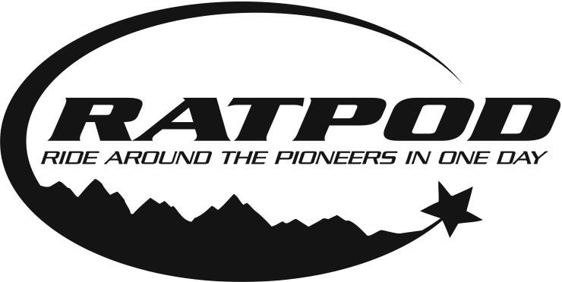

COVID-19 & What to Expect
Cancer doesn’t stop because of this crisis, and neither will we. But Camp Mak-A-Dream will implement a variety of new protocols in keeping with current guidance on event attendance from the CDC, state, city and other local agencies to keep our participants, volunteers, staff and host community as safe as possible. These practices will be reviewed 90, 60 and 35 days from event day and may be adjusted as directed by evolving medical information to ensure your safety.
COVID-19 has considerably effected event planning and execution details. As in-person gatherings return, Camp Mak-A-Dream is learning from industry experts and other nonprofits across the country. We are focused on following the best practices.

Overall Safety Protocols for 2021
- A rider cap of 250 will be implemented and will not be adjusted without written consent from the local health department.
- The event will be reviewed through a rigorous health and safety mitigation process with multiple checks and balances to ensure the best and safest environment for participants, staff, volunteers, vendors, and sponsors.
- Adjustments to ride components will be made based on the current conditions of disease transmission, vaccination rates, and restrictions per jurisdiction. Evaluated 90, 65, and 35 days from the event.
- Personal responsibilities will be communicated to rider, staff, and volunteers prior to the event via phone, email, social media, and event website updates.
- All efforts will take place to make sure our riders, staff, and volunteers have the most up to date information available.

Event Safety Protocols
- Pre-Event COVID-19 self-screen will be required of all riders, staff and volunteers.
- Hand sanitizer will be available throughout the event including packet pickup locations, course stops, and in and around portable toilets.
- Face coverings will be required for all riders, volunteers, and staff throughout the event. Riders may remove their masks when out on the road.
- Event signage will promote safe social distancing practices including maintaining 6 feet of distance or more between others.
- Dedicated lanes and waiting spots will be provided to aid in physical distancing in areas where cyclists congregate such as packet pick-up, start line, and restrooms.
- Anyone at increased risk or exhibiting symptoms of COVID-19 will be directed to stay home.
- Staff and volunteers will be provided gloves or other PPE if their role requires additional interaction (ex: plastic shields, disinfectant, etc)

RATPOD Unlimited Option Available
If deemed unsafe to hold the RATPOD in person or a cyclist does not feel comfortable participating in the modified in-person experience, our RATPOD Unlimited option exists for each rider to stay connected.
RATPOD Unlimited: Registration Fee – $25

What to Expect at Packet Pick-Up
- Packet Pick-up will take place Friday immediately prior to the ride.
- Goodie bags will include rider packet, t-shirt, jersey if earned, and sponsor swag.
- Packet Pick-up areas will be outdoors with enforced social distancing, crowd control and mask requirements.
- If conditions require, Packet Pick-Up will transition to a drive-thru option.

What to Expect at the Start Lines
- All participants will receive a designated start time.
- Start times will be staggered with no more than 50 riders starting at one time.
- Staging areas will be setup on campus of UM Western and participants must stay in their respective area until their wave is called. Please use social distancing protocols and stay in your designated staging area until called.
- Start Line entry points will be one-way with significant distance of 6 feet or more.
- Self-serve bag drop will be available. Be sure to place a luggage tag from your rider packet on the bag.
- Riders will be given an opportunity to select their start time two-weeks prior to the event.
- Consideration will be taken for teams to start together.

What to Expect on the Routes
- Cyclists will be encouraged to follow physical distancing protocols throughout the ride.
- SAG vehicles will be available on the route with capacity limited to 50% to ensure rider and volunteer safety.
- Masks will be required in SAG vehicles to ensure safety. SAG vehicles will be equipped with extra masks.
- Cyclists must bring their own water bottles to fill at course stops.
- Should you require a return trip to Dillon via bus, buses will be located at the Polaris breakfast stop and the Wise River lunch stop. Buses will be limited to 26 occupants for safety.
- Masks will be required on buses. Hand sanitizer will also be provided on buses.

What to Expect at Course Stops
- Masks must be worn at all times by cyclists, volunteers, staff, and vendors while at stops, unless eating or drinking.
- Masks will be on hand at stops in case a cyclist has lost their mask on the route.
- Individually packaged food/snacks/whole fruit available as self-serve for cyclists.
- Volunteers will restock items, but not serve cyclists.
- Individual packets of sports drink at the hydration area to mix into your water bottles.
- Plastic sheeting or enhanced distances between volunteers and cyclists will be included based on the current disease transmission rates by location.
- Volunteers will be on site to direct cyclists to park their bike at a safe distance from the food and hydration area and put their masks on if they have been removed.
- Portable toilets will be staged apart from one another with hand sanitizer stations.
- All cyclists will be required to dispose of their own recycling and trash in designated bins.
- Dining tables and chairs will be spaced for social distance with a max capacity of 8 per table.
- Building occupancy will be reduced to 50% capacity or as directed by the CDC at time of event.

What to Expect at the Finish Line
- Post-Ride festivities will take place at the UM Western Campus and setup to ensure social-distancing protocols.
- POD style seating will be utilized with a max capacity of 8 per table.
- Beer garden will be set-up for social distancing protocols, staffed by volunteers.
- Post-ride meals will be served by UM Campus staff.
- Please sit & eat only with the RATPOD group you have arrived with and follow social distancing protocols.
- Hand sanitizer stations located throughout the finish line site.
- Masks will be available in case cyclist lost their mask on the route.
- All cyclists will be required to dispose of their own recycling and trash in designated bins.
We will continue to re-evaluate the above protocols and look forward to working with our riders, our staff and our volunteers to provide a safe event for all.

