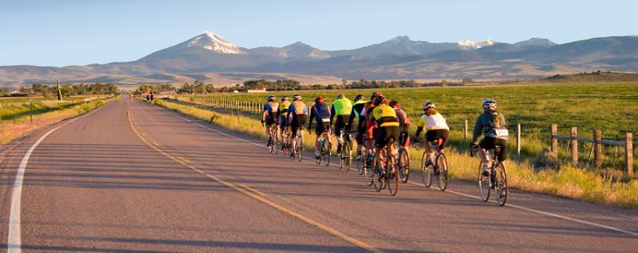StANDARD 127-MILE RIDE
RATPOD's 127-mile course starts and finishes in Dillon, Montana, (elev. 5100 ft.) in front of the University of Montana-Western Campus, Matthews Hall lawn, at 710 S. Atlantic Street. Riders head south on Atlantic Street then turn left on Hwy. 91 south. At mile 3.6, we turn right under I-15 and onto Hwy. 278 west. The ride heads west on Hwy. 278; muscles twitch as you climb to an elevation of 6780 ft. over Badger Pass (and the first water stop). Riders will then head north into the Grasshopper Valley (elev. 6200 ft.) on Hwy. 484 (Pioneer Scenic Byway). Ten miles of gentle uphill grades lead riders to the breakfast stop at the Montana High Country Lodge, just outside of Polaris (mile 30).
After fueling up, riders will begin to climb through the center of the Pioneer Mountains. In the east tower the younger, more jagged portion of the Pioneers. In the west rise the older, more eroded portion of the Pioneers.
The climb up Hwy. 484 from the breakfast stop greets satiated riders with an 8% kick-up that lasts for about 0.5 mile. The climb moderates to about 4-6% hereafter for four more miles. Riders crest the scenic byway at the Crystal Park turnout at nearly 8,000 feet in elevation. Alpine meadows full of camas flowers, sub alpine fir and vistas of the rugged eastern side of the Pioneers reward RATPOD riders.

The route now begins a steep two-mile descent through tight corners and Lodgepole pine. Hwy. 484 joins Wise River for a gradual 20-mile descent to the lunch stop in the town of Wise River, site of the second food stop (mile 70).
Fueled and ready to ride, the route heads downstream to the town of Divide. Hwy. 43 ends and riders turn south on the Old Butte Hwy., accompanied by the Big Hole River. The Old Butte goes through Melrose (mile 85), to the Sportsman's Motel where there is another water (and watermelon) stop, up over Hilltop, then into the town of Glen, where riders stop into Willis Station, home of the legendary pie & ice cream stop (mile 107), the third and final food stop of the route. The Big Hole River bids farewell and flows northeast joining the Ruby and the Beaverhead at the Jefferson River.
We continue south on the Old Butte Highway, bringing it home into Dillon. Turn right on Montana Street and travel 0.5 miles, and then left on Helena Street and ride another 0.5 miles. We make a final right turn on Atlantic Street and cruise, limp, push, or wobble the final mile back to the University of Montana-Western lawn at Matthews Hall (mile 130) where live music, smokin’ barbecue and cold beverages will greet our peloton.
* Route and food stop locations are subject to change due to construction or other unforeseen circumstances.

FOOD & WATER STOPS
THERE ARE FIVE OFFICIAL STOPS ALONG THE 130-MILE ROUTE. LOCATION, MENU AND SERVICES ARE LISTED BELOW. STOP LOCATION MILEAGE IS APPROXIMATE.

STOP #1: WATER STOP (ROADSIDE, BADGER PASS, MILE 14 OF ROUTE):
Water, sport drink (Porto-lets, sunscreen, bug spray, clothes drop service supplies)
STOP #2: BREAKFAST STOP (POLARIS, HIGH COUNTRY LODGE, MILE 30 OF ROUTE):
Water, sport drink, custom-made burritos, bagels, PB&J, fruit (Porto-lets, sunscreen, bug spray, clothes drop service supplies)
STOP #3: LUNCH STOP (WISE RIVER COMMUNITY CENTER, MILE 70 OF ROUTE):
Water, sport drink, sandwich-fixings (meats, cheeses, lettuce, tomato, condiments (Porto-lets, sunscreen, bug spray, clothes drop service supplies)
STOP #4: WATERMELON STOP (MELROSE, SPORTSMAN MOTEL, MILE 85 OF ROUTE):
Watermelon, water, sport drink (Porto-lets, sunscreen, bug spray, clothes drop service supplies)
STOP #5: PIE STOP (GLEN, WILLIS STATION, MILE 107 OF ROUTE):
Hand-made pies, choice of ice cream products, water, sport drink, Coca-Cola soft drink products (Porto-lets, sunscreen, bug spray, clothes drop service supplies)

