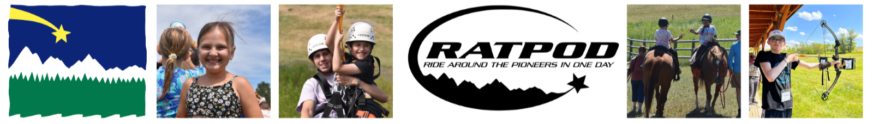
2024 Rider Fundraising Toolkit

Hello Riders –
Welcome to your Rider Fundraising Toolkit for RATPOD 2024. This toolkit includes resources for you to use as you fundraise and share Camp’s story with your friends and family. Customize this content to connect with your network and communicate the impact to each of our Campers.
RATPOD is the single largest fundraising event for Camp Māk-A-Dream and is crucial to continue our mission. With your help, our goal is to raise $300,000 to support those impacted by a cancer diagnosis.
We truly appreciate your participation in RATPOD, and we can’t wait to see you in Dillon this spring!
Sincerely,
Camp Māk-A-Dream Staff

This toolkit includes:
- Fundraising tips to help get you started and boost fundraising creativity
- Email template to customize and send to your network
- Fundraising postcard to share with your network
- Social media posts to share online and spread the word

Fundraising Tips
Set a goal. The first step to fundraising success is to set a realistic goal. All RATPOD participants are asked to raise a minimum of $100. If you raise $500, you will receive a commemorative RATPOD biking jersey. And the ultimate glory comes with raising more than $1,000 and earning a yellow commemorative jersey. Your goal should be a challenge, but not unachievable. You'll be surprised at how much you can raise when you put your mind to it.
Craft your message. Tell people what you're doing, why you're doing it and tell them how they can help you. Everyone has a cancer story – tailor the message to be unique like you. Start with the template provided in your toolkit, and then add your personal story and customize it as you reach out to your contacts.
Make a specific ask. The most successful fundraisers are ones who ask for something specific. Instead of asking your potential donor if they would consider making a general donation, ask them to donate a specific dollar amount. Of course, every dollar counts; but you are more likely to have a higher per-donation average with specific asks.
Contact everyone you know. Your best friends, your family, that guy you used to work with – everyone. Make a list of contacts from every part of your life and ask them to help support you. Sometimes donations come from the most unexpected of people. Camp Māk-A-Dream and cancer is a cause that hits home – start sharing it with everyone you know.
Use social media. Your Rider Fundraising Toolkit contains social media posts that you can customize and share. These channels are a great way to reach a larger audience but remember that social media can be inundated with information. Sharing directly to others’ profiles, tagging contacts, etc., is a great way to create a more specific call to action.
Send a text. Sometimes in the hustle of daily life, people read emails then forget to respond, but text messaging gets immediate attention. Send text to your friends and family that includes a direct link to your fundraising site and why they should support your RATPOD ride and Camp Māk-A-Dream!
Don't give up. You may hit a point where the donations stagnate. You may feel as though you were doing so well and now you can’t quite reach your goal. Or maybe you’re just getting started fundraising, and everyone is telling you, “Later” or “Next time.” DON’T GIVE UP. It’s a challenge and you’ll overcome it. Persevere just as you will in the Pioneers.
Always give thanks! Check your fundraising page, at any time you can see who has donated and how to get in touch with them. Be sure to send a personal thank you to every donor. Shout outs on social media are great, but it is even better if you take the extra few minutes to send a personal note of gratitude.
Fundraising Email Template
Directions:
- GATHER a list of emails for family, friends, coworkers, cycling groups, etc.
- CHOOSE a subject line for your email (or create your own!)
- INSERT (1) a link to your fundraising page, (2) a personal note about why this cause is important to you, how your life has been impacted by cancer, your individual or team fundraising goal, etc.

Subject options: Help Me Support Camp Mak-A-Dream / I Need Your Help to Make a Difference / RATPOD 2024 / Exciting News to Share / More Than A Summer Camp…
Hello friends and family,
I have some awesome news to share with you! I am thrilled to announce that on June 22, I am participating in RATPOD – a charity cycling event that benefits Camp Māk-A-Dream, an oncology camp in western Montana that is entirely FREE to participants.
I am personally raising money to support this great organization, and I need your help to make it happen. Every donation, no matter how big or small, will make a difference in the lives of those affected by cancer. Your support will help fund programs and activities at Camp Māk-A-Dream that create lasting memories and bring a smile to the faces of those who need it most.
"Cancer isn't as scary at Camp because we are reminded that we aren't alone" – 2023 Caregivers Retreat Participant
Camp Māk-A-Dream is more than a summer Camp... it is a place where survivors can feel connected, understood and revitalized. Cancer can be a lonely and isolating journey, but Camp provides a safe and supportive environment for participants to experience joy, learn new skills, and create lifelong friendships with others who truly understand what they have been through.
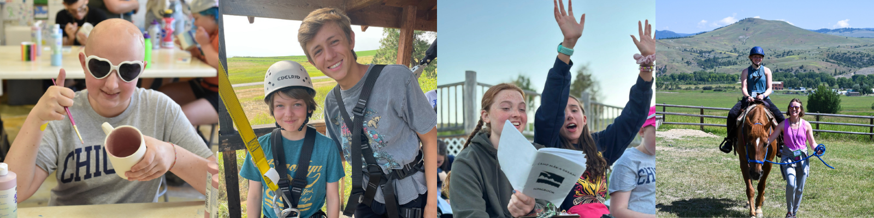
“The confidence that kids gain at Camp allows them to be braver in the real world in terms of making friends and advocating for themselves. It sure was for me. Camp has transformed my life in the best way possible.” – 2023 Teen Heads Up Conference Participant
So, let's join forces and create unforgettable experiences for people affected by cancer. Visit my fundraising page today and donate to this incredible cause (INSERT YOUR FUNDRAISING LINK). Thank you for your support!
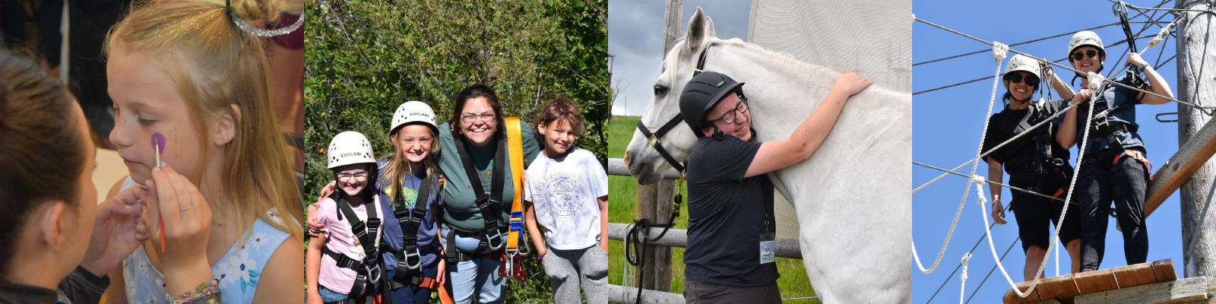

Fundraising Postcard
Directions: Print this flyer to share with your neighbors or post in the breakroom at your office. QR codes make it easy for people to donate!
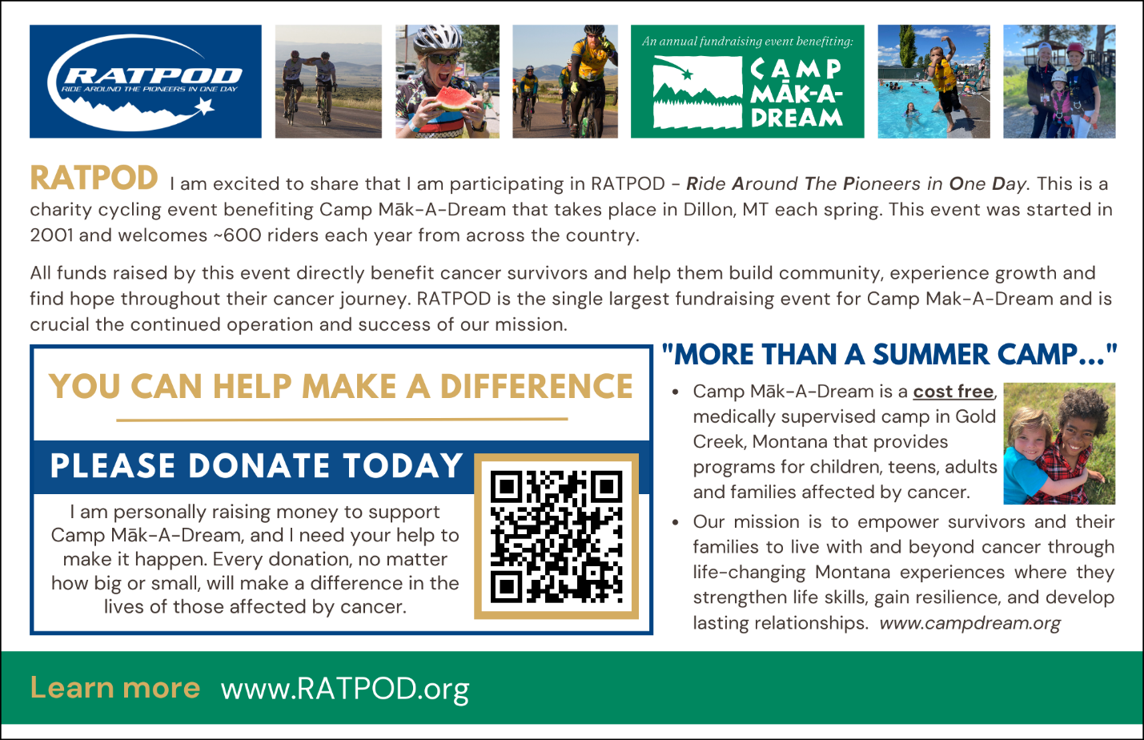
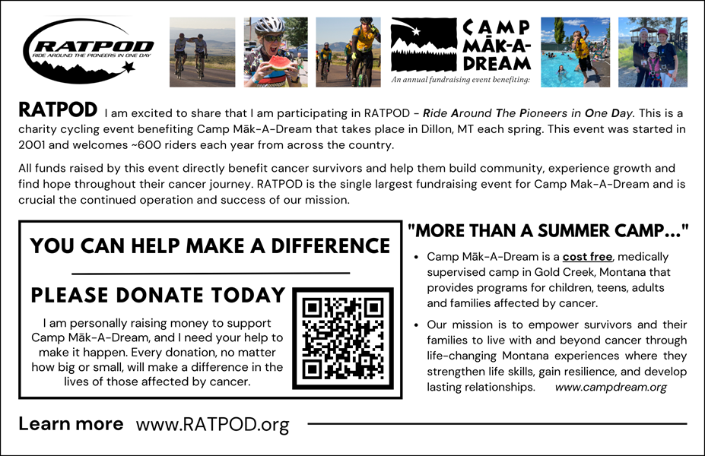
Social Media Posts
Directions: Choose from the social media post options on the following pages to share with your online networks. Add your fundraising link and edit the language for a personalized approach.
Tip: Right click on each image to ‘Save as Picture…’ to your computer. Then you can upload it to your social media accounts and share it with your friends and family.

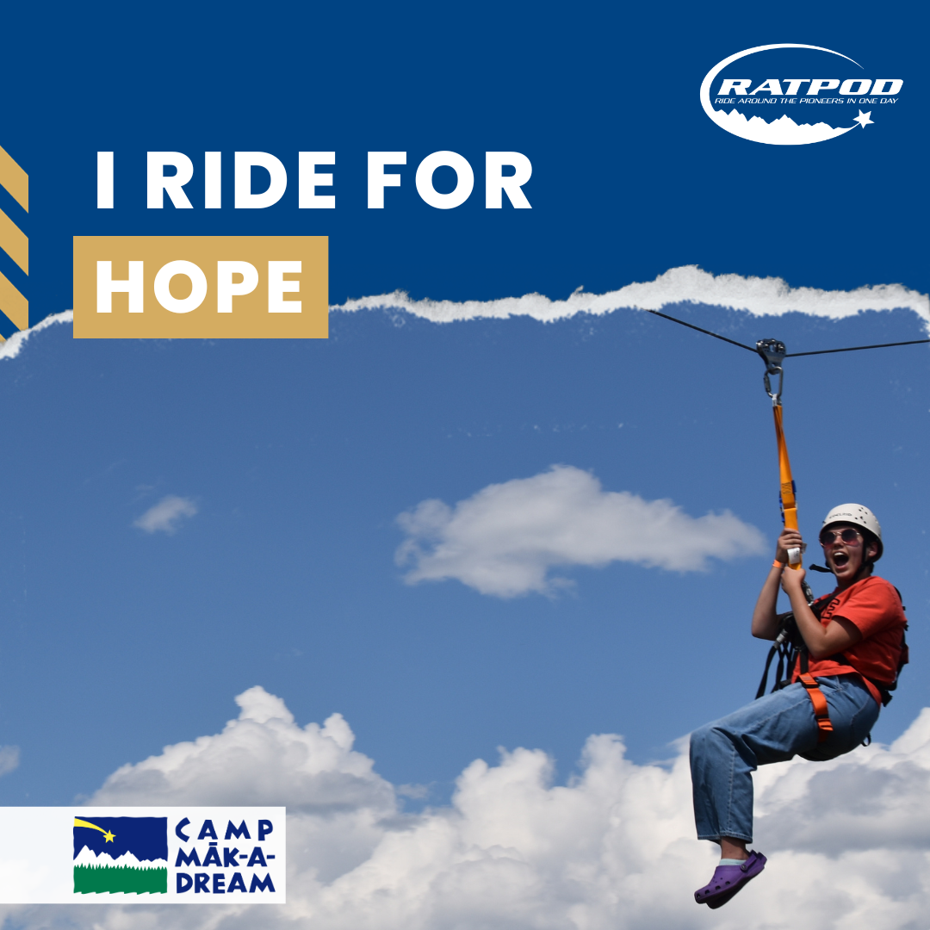
I ride for HOPE. "Thank you for helping me spread my wings. This week has been so uplifting to my spirit."
This June I am riding in a charity cycling event, RATPOD, to raise money to support Camp Mak-A-Dream, an oncology camp in western Montana. This camp brings together cancer survivors from across the country and creates an unforgettable experience that helps them strengthen life skills, gain resilience, and develop lasting relationships.
Help me make a difference in the lives of these fighters by donating to my fundraising page today: INSERT YOUR FUNDRAISING LINK

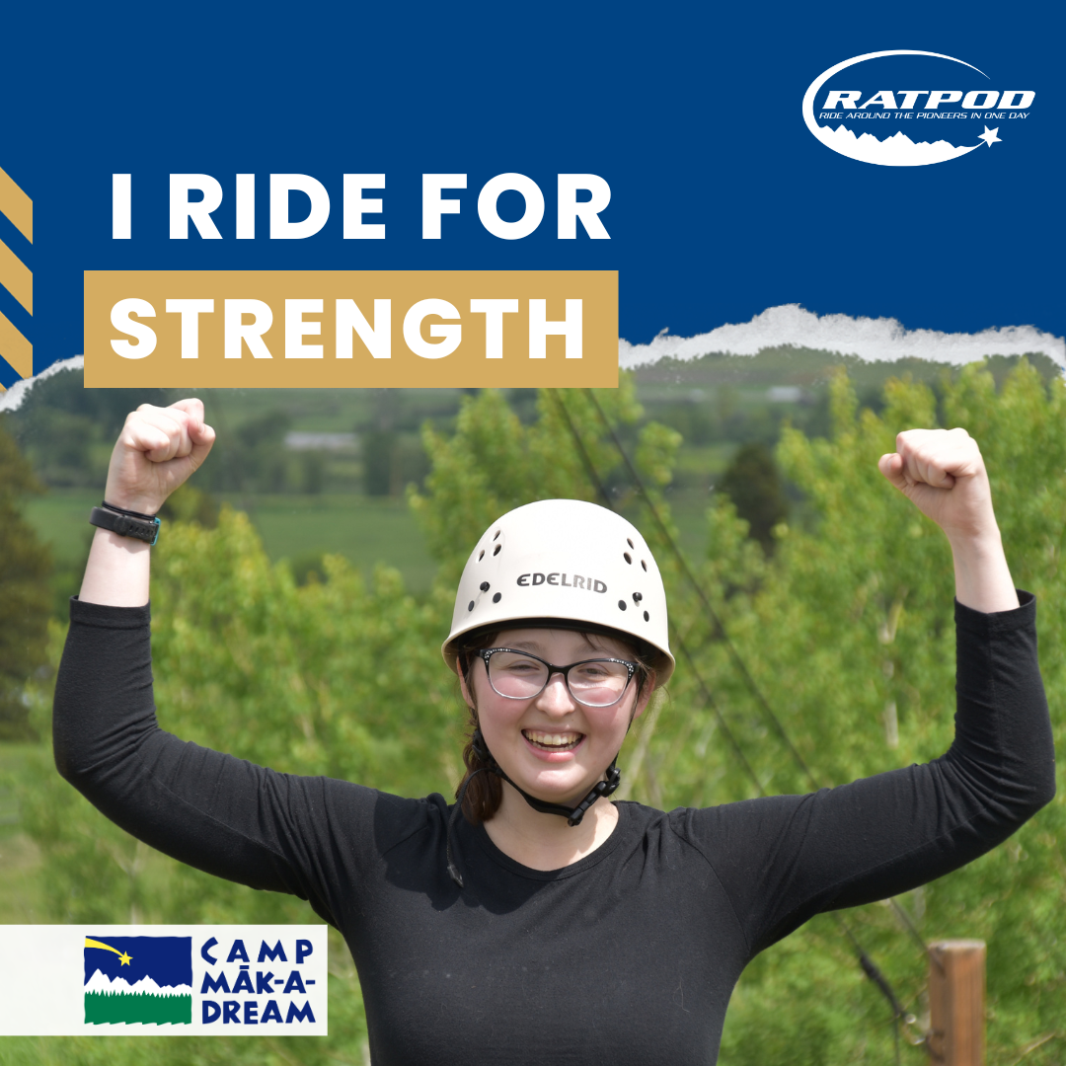
I ride for STRENGTH. "Thank you for helping me be myself."
Camp helps build confidence and creates a safe environment for participants to try new activities and push beyond what they ever thought was possible.
I am calling on you to join me in making a meaningful difference in the lives of these strong survivors by donating to my fundraising page: INSERT YOUR FUNDRAISING LINK. Together, we can help campers achieve their dreams and create a brighter future!
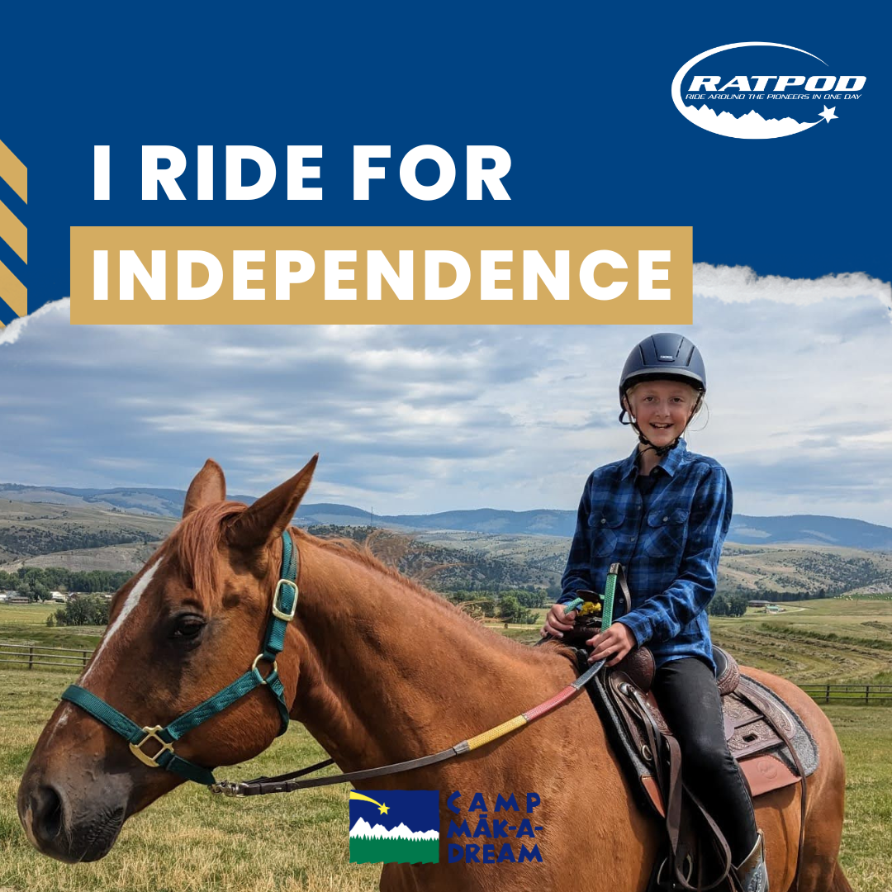
I ride for INDEPENDENCE. “I experienced just how wonderful people could be and gained more confidence in being around people like me.”
Camp provides a unique opportunity for cancer survivors to receive psychosocial support, build friendships, and increase their self-esteem through a variety of recreational activities and workshops.
Help me raise money to support this invaluable camp experience by donating to my fundraising page: INSERT YOUR FUNDRAISING LINK
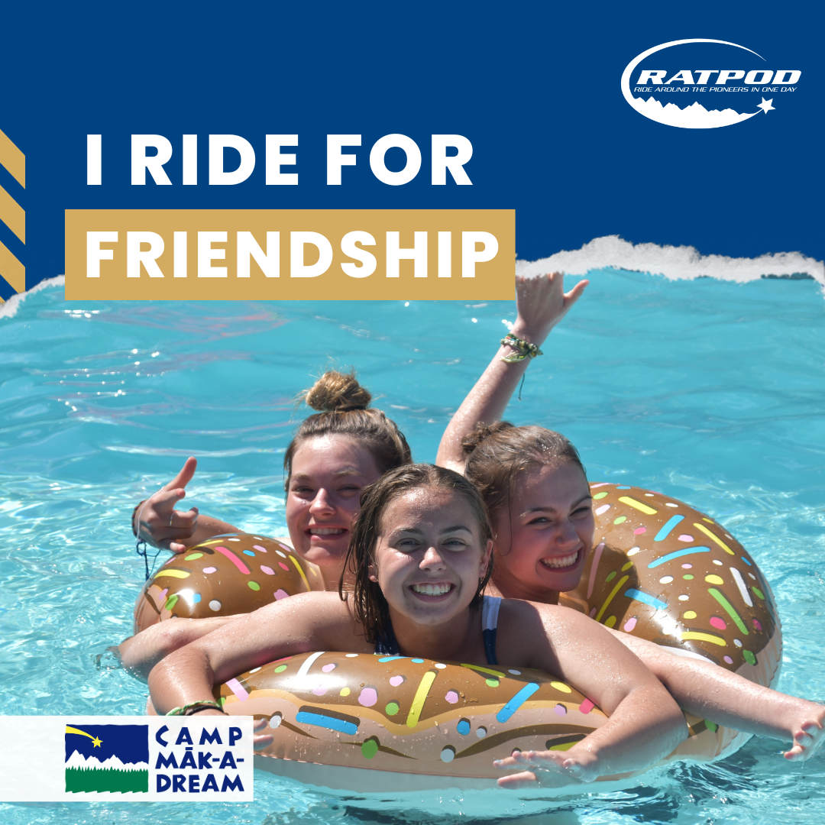
I ride for FRIENDSHIP. "I was diagnosed with a rare brain tumor in Dec 2022 and I had never met anyone else like me until now! The experiences and friendships I had this week were unforgettable."
One week at Camp builds genuine friendships that create a lifetime of support. By donating today, you'll be helping us provide a safe and nurturing environment where kids can connect with each other and create memories that will last a lifetime. Donate on my fundraising page: INSERT YOUR FUNDRAISING LINK
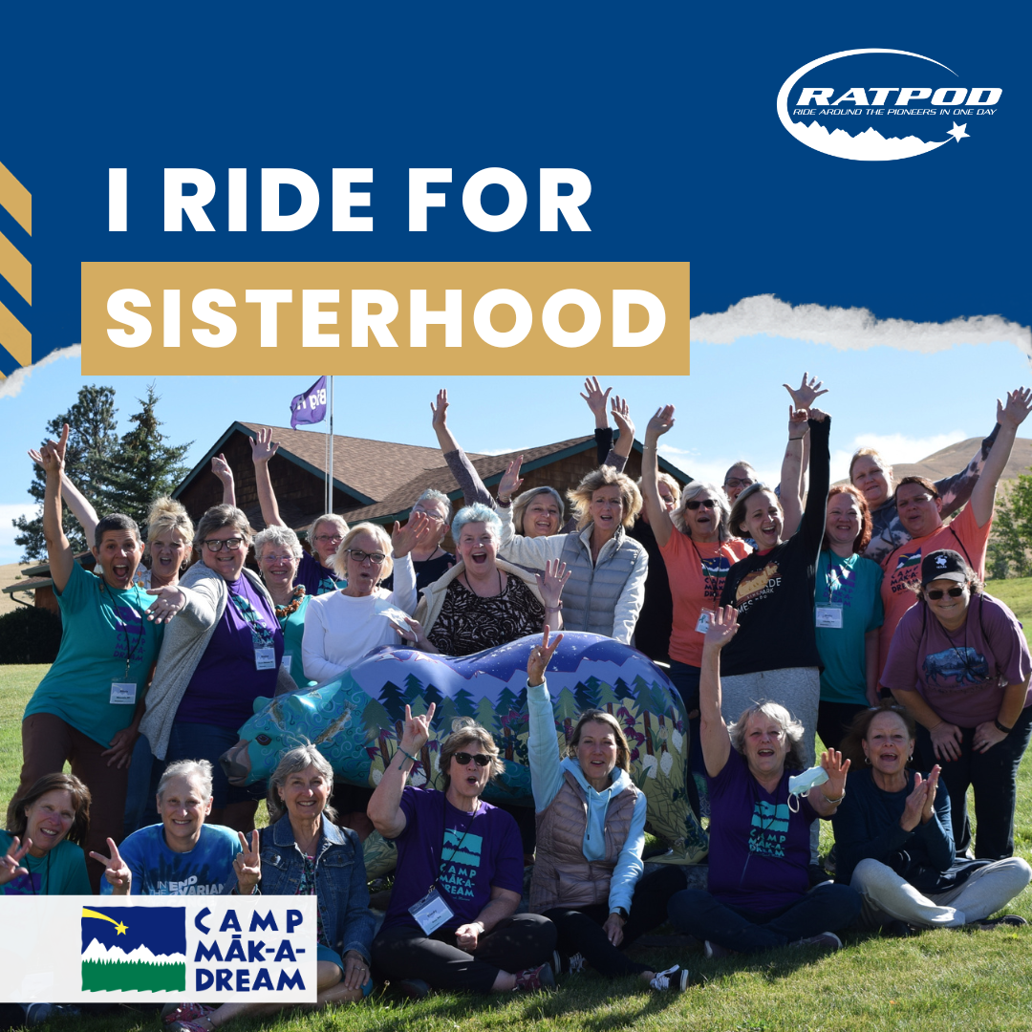
I ride for SISTERHOOD. "Camp Māk-A-Dream was phenomenal. It was a sanctuary that allowed me to be myself and be honest about my fears, my feelings and my future. It helped me remember what I'm fighting so hard for – the ability to enjoy life and share it with others."
Help me support these strong cancer survivors by donating to my fundraising page: INSERT YOUR FUNDRAISING LINK

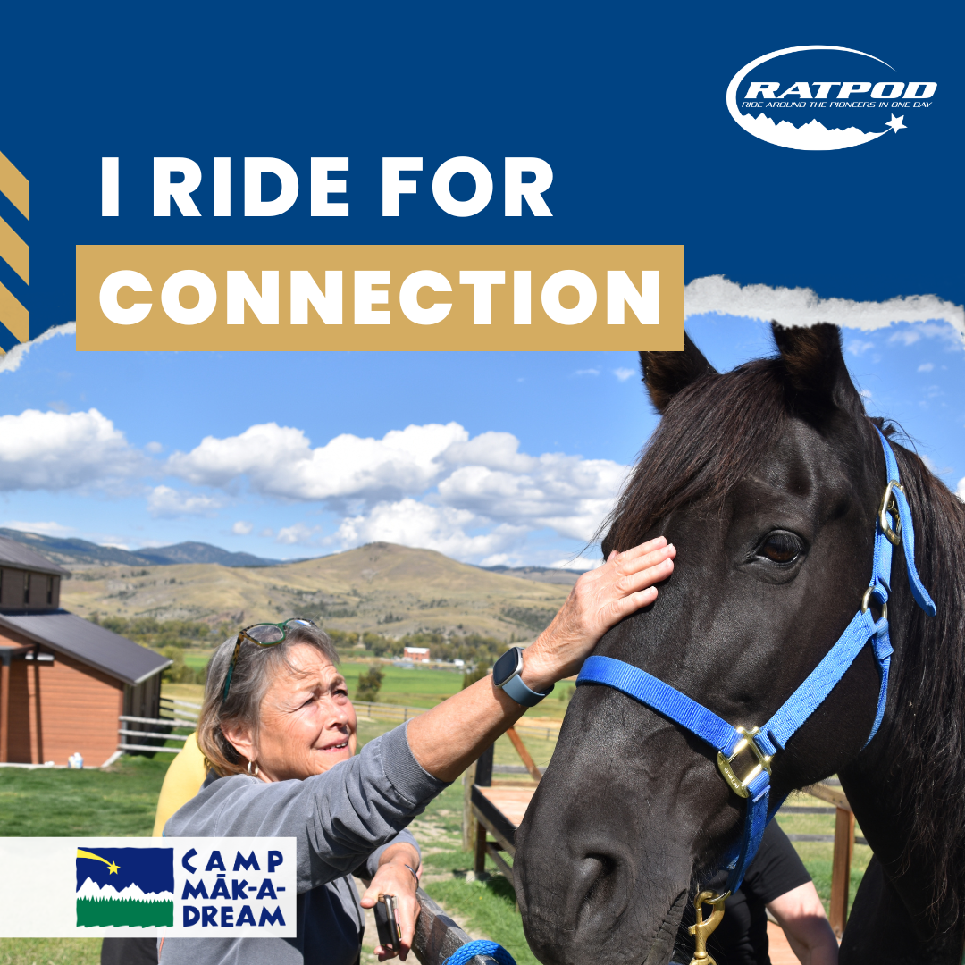
I ride for CONNECTION. “My favorite part about camp is knowing that I'm not different or weird here.”
Camp Māk-A-Dream creates an innate sense of community and understanding that you can’t find anywhere else. The bonds formed at camp last a lifetime.
Together, we can ensure no one has to go through cancer alone. Please consider making a donation: INSERT YOUR FUNDRAISING LINK

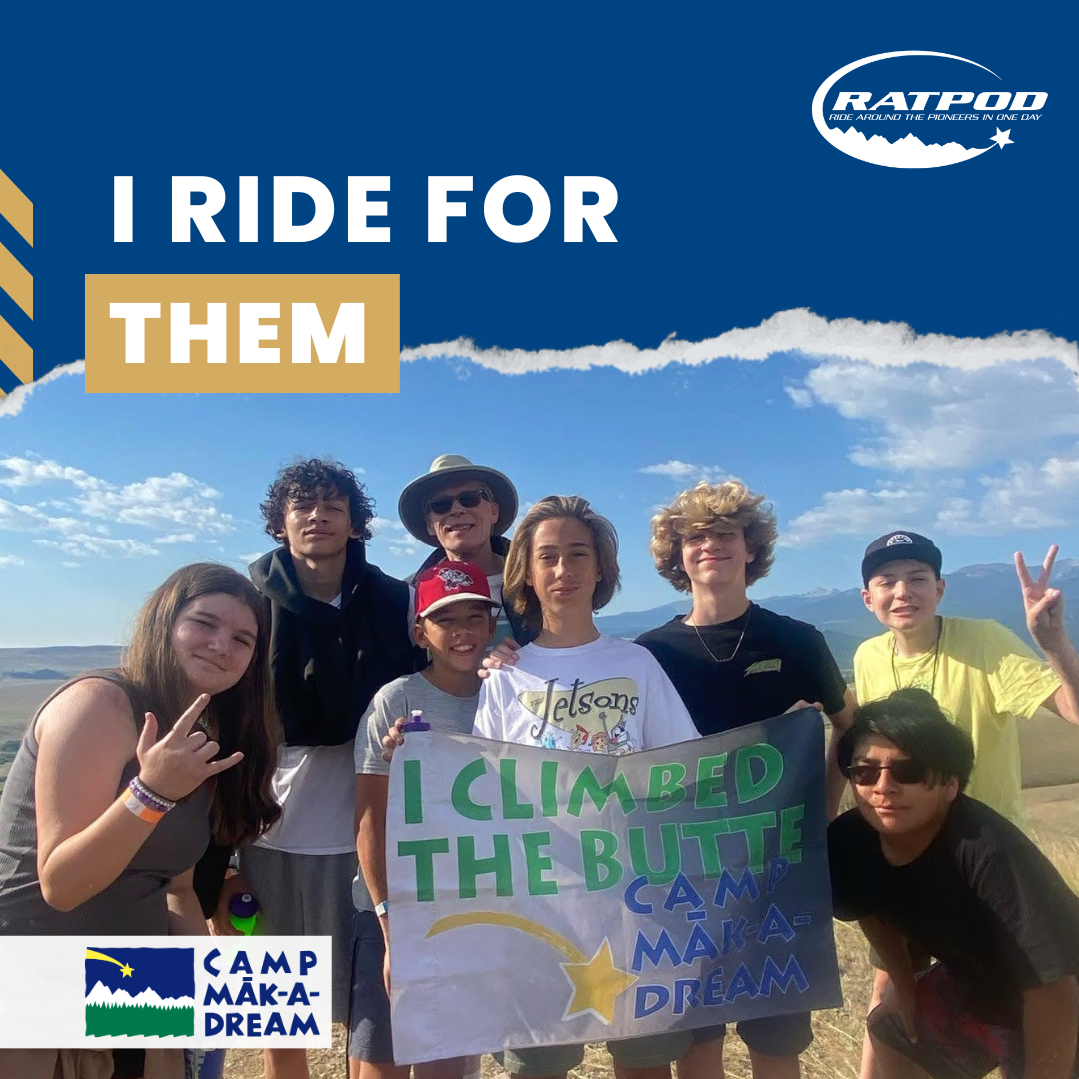
I ride for THEM. "Camp means a lot to the campers here, and many of us look forward to it all year long."
RATPOD is right around the corner! Let’s rally for the people who need it most. Help me support Camp Māk-A-Dream by making a donation today: INSERT YOUR FUNDRAISING LINK

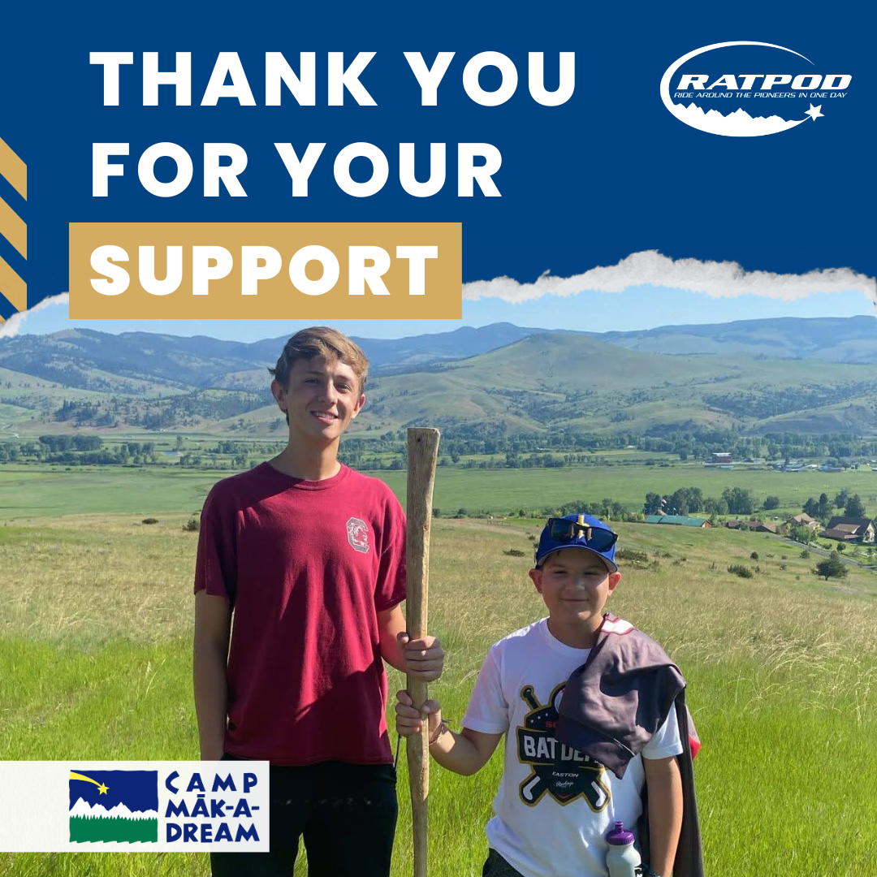
Thank you. I am so grateful for your support and dedication to this important cause. Thank you for helping change lives at Camp Māk-A-Dream. Learn more about this incredible organization at www.campdream.org

