Welcome to the Team!

We look forward to you joining us as a volunteer at the Spring Women’s Cancer Retreat from May 4-8, 2023!

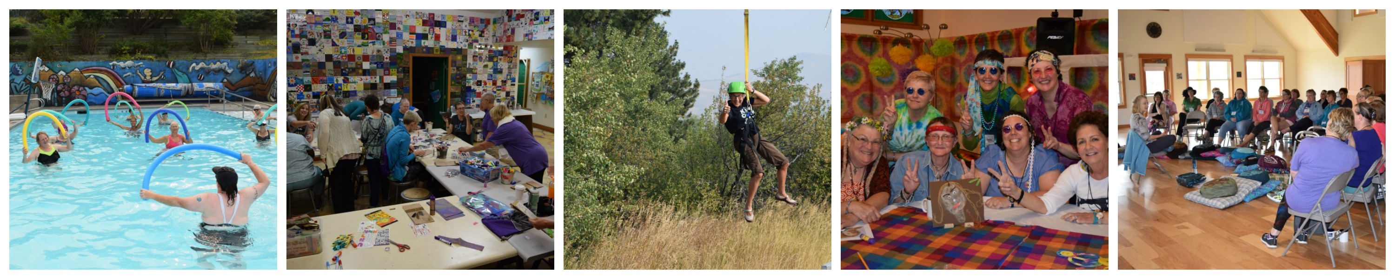
Thank you so much for volunteering your time at Camp. There is a lot of information included in this packet, which we hope will answer most of your questions. Please read it all carefully and contact us if you have any questions or need additional information.

Because of the population we work with at Camp Mak-A-Dream, it is important we ensure that we are doing everything within our power to keep our participants safe. People travel to camp from across the country and several of our participants are immunocompromised. During the upcoming season, we may implement a variety of infectious disease mitigation strategies. Part of coming to Camp will include agreeing to follow all of our policies.
Our goal continues to be keeping everyone’s well-being and safety as our top priority.

Information to Help Prepare You for Your Trip

Activities: The retreat will be filled with numerous educational and recreational opportunities including guest speakers and workshops on a variety of topics. Be prepared to enjoy good food and conversation, entertainment, cozy accommodations and free time to enjoy each other’s company.

Our team has developed a fun, engaging schedule for each session, including one evening devoted to this year’s theme…Around the World (think, Amazing Race combined with a trip to your Dream Destination)!

If you haven’t been to Camp before, you will soon experience theme night which combines decorations, interactive games (and maybe a little friendly competition), great food, the opportunity to learn a little something, the chance to come dressed for your Dream Destination, Trip, Adventure or Activity and have a great time!

Get creative and please keep in mind that we will be celebrating numerous cultures Around The World through foods, décor, fun facts and activities. We ask that you be sensitive to all cultures and their peoples. If you would like to ‘dress up’, please ensure your costume and/or props are respectful and align with this ideology. If you are questioning the appropriateness of your costume idea, maybe consider a different option. We also will have some items at Camp that you are welcome to borrow.

Travel Information: Your volunteer position has been confirmed, so you can refer to the following guidelines and start planning your travel arrangements at your convenience. Volunteers may either drive themselves directly to the Camp facility in Gold Creek, or fly into Missoula, MT. Please plan to arrive on the first day of the session and depart on the last day of the session. If you are flying into town prior to the first day of Camp, please see the housing options below and plan to be back at the airport no later than 1:00pm MT on the session arrival day to meet our staff.

Driving
- Camp Address: 727 Camp Mak-A-Dream Road, Gold Creek, MT 59733
- Camp is located just off I-90 (approx. 65 miles east of Missoula and 60 miles west of Butte). Take Exit #166 (Gold Creek) and head south – towards the river - about one mile. When you see the little white church, turn right, pass under the 6C sign, then turn left passing under the Camp sign, drive up the hill and park in the parking lot on the left. Grab your things from your vehicle, walk across the bridge and stop at the office in the Health Center/Office to check-in.
  - Arrival: Please arrive at the Camp property between 2:00-3:00pm MTN.
  - Departure: Volunteers who drive to Camp typically leave campus by late morning.
Flying
- When booking a flight, please consider looking into travel insurance, refundable flights or flights you can receive credit vouchers for in the event that you or Camp needs to cancel for any reason. Camp Mak-A-Dream is not responsible for any costs in the event that it is necessary to cancel the camp session.
- Please book your flight into Missoula, MT (airport code MSO). Camp staff will meet you at the airport and transport you to the camp facility (and back for your return trip).
  - Arrival: Please book a flight that arrives mid-day (by 2:00pm MTN on the first day of your session, if possible). If this is not possible, please contact us to make alternate arrangements.
  - Departure: We suggest booking a flight that leaves Missoula by 2:00pm MTN on the last day of your session. We do not plan Camp activities for departure day, so you won’t miss anything if you have an early flight.
  - Keep in mind that our facility is an hour drive from the airport, so if you have a morning flight it will mean leaving Camp very early. That said, if you need to depart on an early flight, we will make arrangements to get you to the airport on time. If you book a late afternoon or evening flight out of Missoula, please be prepared to spend some time on your own at the airport.

There should be a link in your Confirmation Email to a Travel Plans Form - this is where you will enter your travel details and itinerary information once you have booked your travel. It asks for the airline(s), flight number(s) and confirmation/ticket number. We need this information for planning purposes and to include you on our airport shuttle vehicle(s) list. Feel free to contact us if you have any questions!

Housing Options before, after or between sessions: If you are volunteering for more than one session, please note that we are unable to accommodate any volunteer housing on campus outside of the actual camp session dates, so if you are coming for multiple weeks and planning to stay in the Missoula area between sessions, Camp can transport you to the Missoula airport. From there you will be on your own for transportation and housing between Camp sessions. Below are some options for places to stay. Mention that you are with Camp Mak-A-Dream to receive our pre-negotiated rates.

Comfort Inn
Offers complementary airport shuttle, hot breakfast, wifi, outdoor fire pit and more. Located close to downtown and within walking distance of the Clark Fork River and University of Montana. For reservations, click the link above or call: 406-549-7600 and mention you are with Camp Mak-A-Dream.

Fairfield Inn
Offers complimentary airport shuttle, breakfast, fitness center and indoor pool with waterslide.
For reservations, call: 406-541-8000 and mention you are with Camp Mak-A-Dream. Discounted rates available for stays on Sunday-Thursday nights. Rooms Fridays or Saturdays are not eligible for a discount.

Weather in Montana: Anything is possible as far as weather goes here in Big Sky country, so the best way to be prepared is to dress in layers. We recommend checking the weather forecast before you arrive (zip code 59733) since temperatures are variable during this time of year. The evenings are cool so we suggest you bring a jacket or something warm. Daytime highs will likely range from 60-70 degrees, with nighttime lows somewhere around 30-40 degrees (or cooler). Camp is also at a higher elevation than most participants are used to (approximately 4,000 ft.) which makes for colder temperatures, frequent windy conditions and physical adjustment for some.
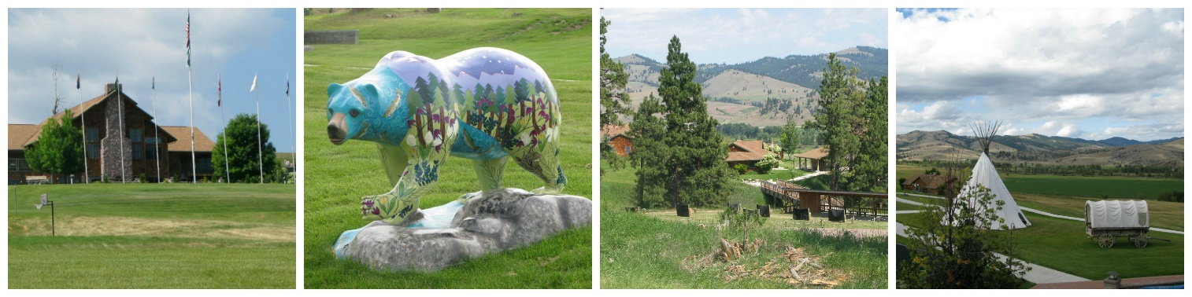
Suggested items to Bring to Camp
- Personal Care:
- Medications for your entire stay * (please see additional details below)
- Soap, shampoo, conditioner
- Toothbrush, toothpaste and any other necessary toiletries
- Lip balm or chap stick
- Hairbrush (Blow drier and curling iron if needed)
- Towel for daily use (if space allows – pool/hut tub towels are available at Camp)
- *Note: Bedding and sunscreen are provided by Camp

- Clothing/Shoes:
  - T-shirts
  - Jeans or long pants
  - Shorts (please note that Dream Team members working in the kitchen are required to have pants long enough to cover 2/3 of your legs or more)
  - Socks and underwear
  - Pajamas
  - Jacket or heavy outer layer (we are not kidding – it gets very cool at night and in the morning)
  - Swimsuit
  - Tennis shoes or closed-toe shoes (required for some outdoor activities & required for all Dream Team members working in the kitchen)
  - Sandals

- Additional Items:
  - Baseball hat or sun hat
  - Sunglasses
  - Banquet Night Attire (casual or dressy - optional, you’re welcome to come as you are!)
  - Costume or props for our Theme Night (see information above about this year’s theme)
  - Cell phone or camera with charger/batteries
  - Cash, checks or credit card to purchase items in our Camp Store and at our Raffle/Auction
  - Headlamp or flashlight
  - Warm Fuzzies* (see more about this Camp tradition in the warm fuzzy section)

- Please Note:
- Personal space in the sleeping areas at Camp is limited, so please bring only what you need
- Camp Mak-A-Dream is not responsible for lost or stolen items
- Lost and found items are kept for a limited amount of time after camp sessions
- Please label all personal belongings including medications, bags and suitcases
- Valuables can be locked in the Health Center office, but we prefer that they stay at home

- What NOT to Bring to Camp:
  - Pets
  - Expensive jewelry or electronics
  - Alcohol, tobacco items, cigarettes (including vapor or e-cigarettes), tobacco products, matches, lighters, fireworks, laser pens
  - Knives, illegal drugs, firearms or other weapons

Medications: If you take any medications, please bring enough medication for your entire stay (including over the counter medications). All volunteer medications must be placed and stored in a secured locked cabinet in the Health Center, but you will have access it to at any time during your stay. If you arrive without enough prescribed medication, we cannot guarantee that we can get access to a replacement supply/prescription and you are responsible for purchasing any necessary medications during your stay with us.

Tobacco/Alcohol/Marijuana Policy: Camp Mak-A-Dream is a smoke-free facility. Smoking is not allowed in any buildings or on campus grounds. This includes all tobacco products, plus electronic cigarettes and vaporizers. Also, alcoholic beverages should not be brought onto campus and the use of marijuana products, including those medically prescribed, is not permitted on Camp property.

Warm Fuzzy Bags: *Staff and campers will make a “Warm Fuzzy” bag to hang in the dining room that serves as a personal mail box for each person to receive small notes and goodies throughout the week. This is a fun and totally optional activity at Camp but often people like to share a special little something with the others in the group – might be a favorite poem, a small trinket from your home state, a sweet treat or word of encouragement. Bags, paper and writing utensils are provided at Camp. Please be mindful that Camp is a diverse community. We ask that you do not bring items with any specific political or religious affiliation.

Internet Use/Cell Coverage: We ask volunteers to limit Internet and cell phone use as much as possible during their stay. Limited open wireless is available on campus, but we discourage volunteers from bringing personal computers or electronic devices to Camp both for security reasons and so as to not detract from being present within the camp community. Refer to the Camp Manual for additional information on this topic. Cell phone coverage can be spotty depending on your provider, but overall is decent.

Camp Store: We have a camp store with items such as hats, apparel, smaller logo items, soda, candy and other assorted items. Payment is accepted by cash, check or major credit/debit cards. All volunteers will receive a complimentary t-shirt to wear during the week and take home with them. This year’s shirt colors are: volunteers – royal blue; campers – dark red.

Raffle and Silent Auction: During the retreat we will host a raffle and silent auction with proceeds benefiting future retreats. Participants and volunteers are welcome, but not required, to contribute items for the auction/raffle. Popular items include things like jewelry and handmade items (purses, socks, quilts, art), or things native to your home state or area. Smaller items are great and may be paired or grouped together for either the raffle or silent auction. Please keep in mind that larger or fragile items are difficult to transport (especially for those traveling by plane), and while Camp is able to ship items home to you, we do ask that the costs of doing so be covered by participants. Please be prepared to provide a description and value of the item to help set the minimum bid, and if it was donated, have the donor information so they may be acknowledged.

Bringing Items with you: You are welcome to bring any items you wish to put in the Raffle/Auction with you to Camp. There will be a place to drop them off upon your arrival.
Shipping Items ahead: If you wish to contribute a raffle or auction item(s) and prefer to ship it to us in advance, feel free to send it to our Missoula foundation office (address below). Please ensure the package arrives at least one week prior to the retreat.
Camp Mak-A-Dream
Attn: Spring Women’s Retreat
2110 S. Johnson Street
Missoula, MT 59801

Please help us spread the word about the magic happening in Gold Creek, MT, by telling friends and family to follow Camp Mak-A-Dream on social media. On behalf of our entire team – thank you for contributing your time, energy and compassion to Camp Mak-A-Dream during the 2023 season. We look forward to sharing an incredibly meaningful week together. If you have any questions, please do not hesitate to contact us. We look forward to seeing you soon!

Children's Oncology Camp Foundation | Camp Mak-A-Dream
P.O. Box 1450 | Missoula, Montana 59806 | Phone (406) 549-5987 | Fax (406) 549-5933 | www.campdream.org
Camp Facility | 727 Camp Mak-A-Dream Road| Gold Creek, MT 59733 | Phone (406) 288-3030

