Instructions for setting up an Individual Peer to Peer Fundraising Page to benefit

- Go to https://app.donorview.com/QjOyZ
  - 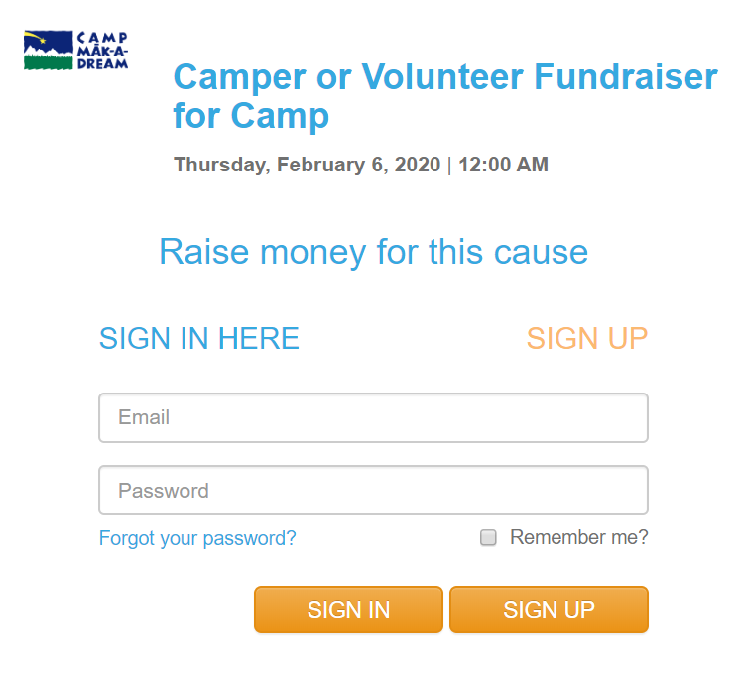
- If you haven’t already, please create a log in to our system by entering your email and a password of your choosing
- At the top, please make sure you are under the “Peer to Peer” tab (not donations, events, etc.)
  - 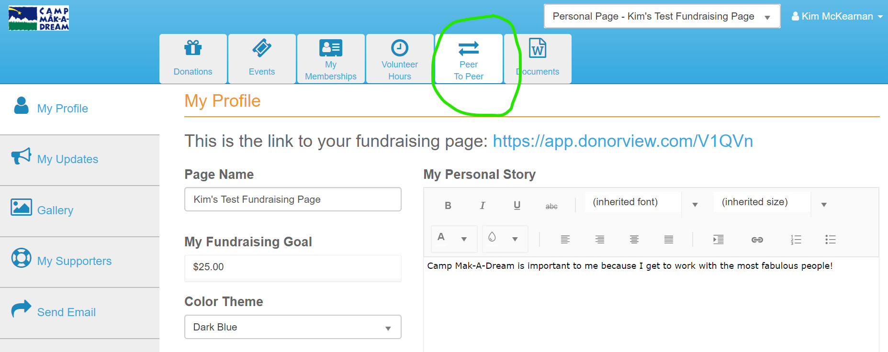
- At the very top, be sure you have chosen “Personal Page- Camper or Volunteer Fundraiser for Camp”
  - 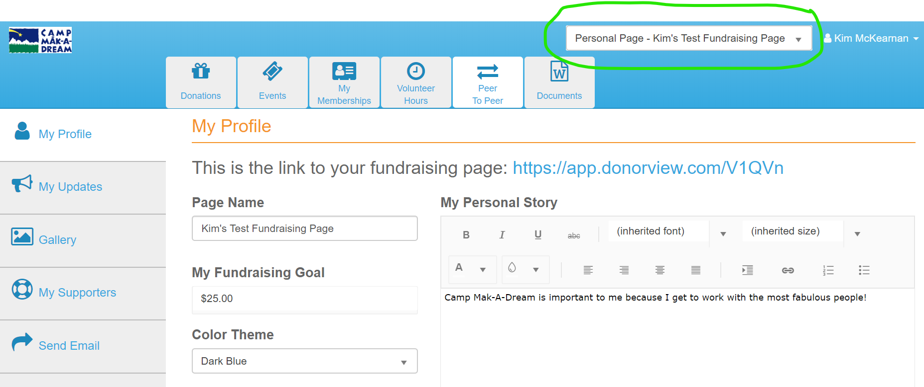
- Under the orange “My Profile” you should see 4 areas that you can personalize. They include: “Page Name”, “My Fundraising Goal”, “Color Theme” and “My Personal Story”
  - Be sure to hit “SAVE” when you are done or whenever you make a change to any of these four areas
  - 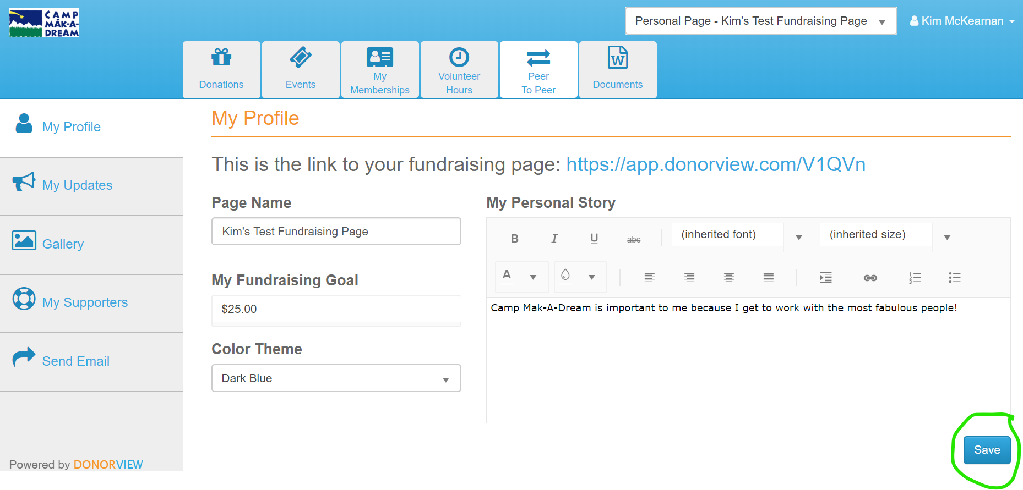
- You’ll be able to see a preview of your page if you scroll down once you’ve saved your personalizations.
- After you’ve completed your personalization, copy the URL/web address at the top of the page (found after the words “this is the link to your fundraising page:”)
  - 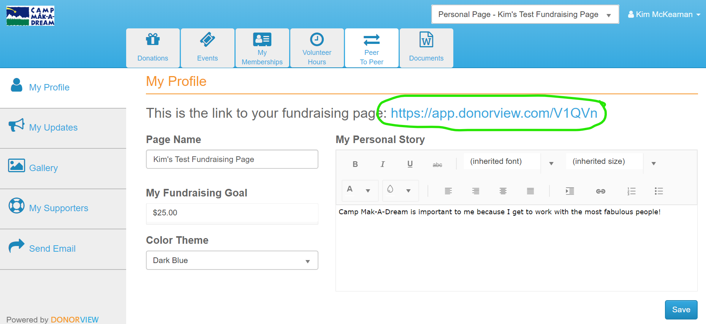
- Then, paste this URL/web address into an email or on your social media to share with others and begin fundraising!
  - Do NOT use the “Send Email” function on the left hand side of the page. Unfortunately, emails sent this way come from a generic email address that most often lands in junk or spam folders.
  - 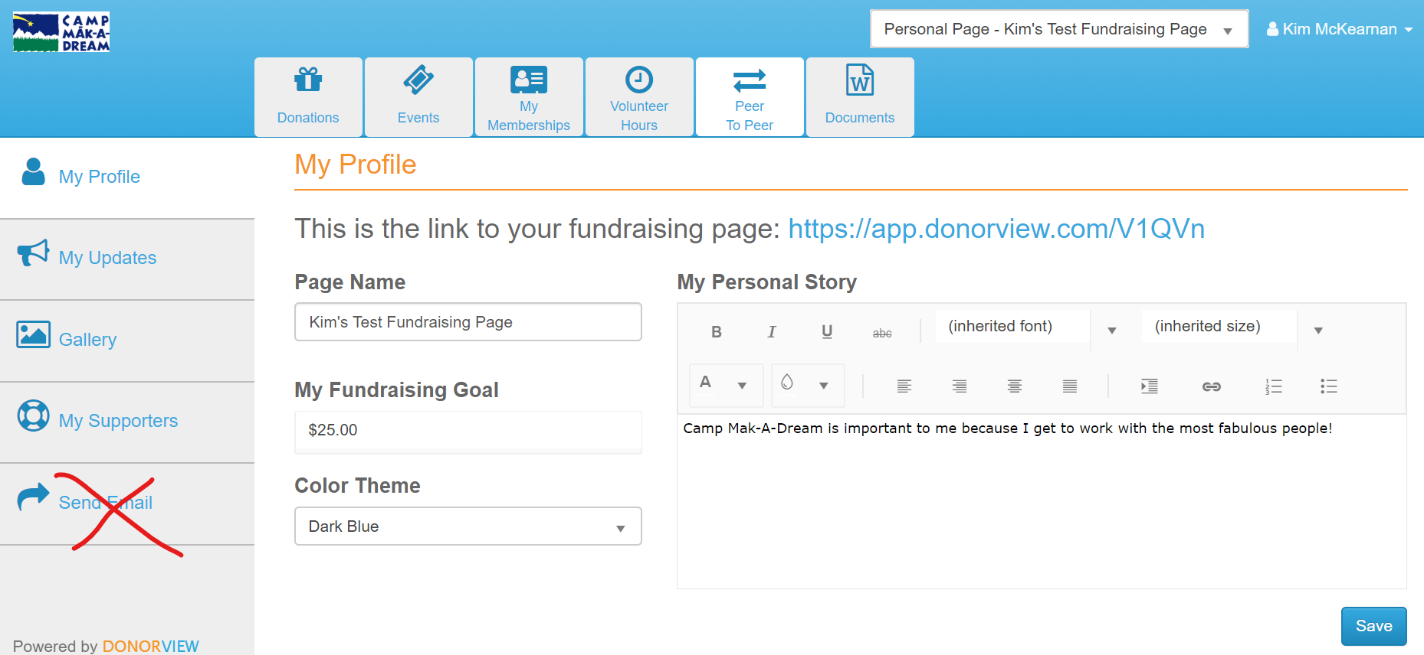
  - Instead, create a personalized email to your friends and family including the URL/web address you’ve copied and send the email directly from your own email address. Automatic thank you emails and donation receipts will be sent to your donors.
- If you have any questions or difficulties when trying to set this up, please don’t hesitate to call the Camp Mak-A-Dream office at 406-549-5987 and ask for Kim. She’ll be happy to help!

Thank you for supporting Camp by creating your own fundraising page!

