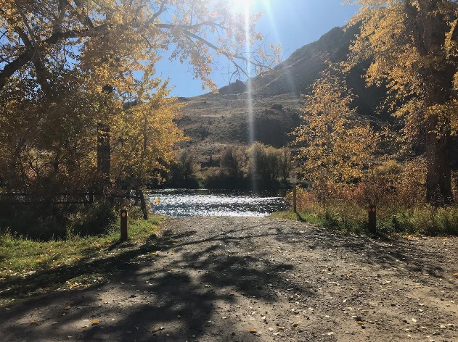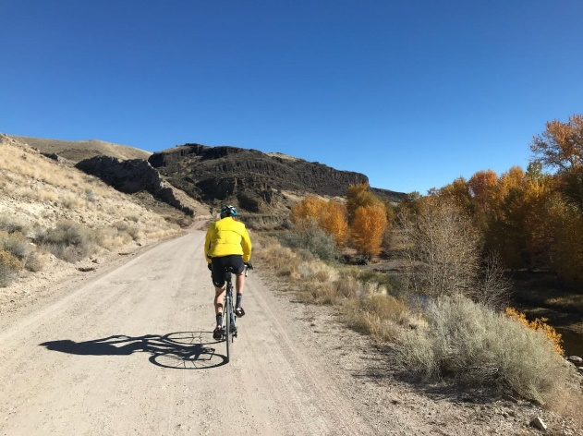
62-MILE RIDE
RATPOD's 62-mile course also starts and finishes in Dillon, Montana, (elev. 5100 ft.) in front of the University of Montana-Western Campus, Matthews Hall lawn, at 710 S. Atlantic Street. Riders head toward Twin Bridges on Highway 41 for approximately 22 miles. Note, there is about 6-7 miles in the middle of the section where there is no shoulder – please use caution.
You will then turn left on Pennington Road-- this is a gravel road. A water stop will be available at this intersection off the road. Pennington Road is beautiful and for the most part, follows the Big Hole River. Riders can enjoy a beautiful brunch stop at Notch Bottom Fishing Access located approximately 10 miles from the turnoff onto Pennington. After brunch it is another 8 miles to Highway 91.
Riders will then have the option to ride north 1 mile for the Glen Pie Stop or head south to Dillon for another 20 miles. The climbing is 1677ft or 500m. This is a true metric ride!
18 miles of this ride is gravel - you can choose to ride on any bike you wish. Our scouting team rode on road bikes with skinny tires and had no issue. We will leave that up to you!
FOOD & WATER STOPS
THERE ARE TWO OFFICIAL STOPS ALONG THE 62-MILE ROUTE WITH AN OPTIONAL THIRD STOP FOR PIE IN GLEN. LOCATION, MENU AND SERVICES ARE LISTED BELOW. STOP LOCATION MILEAGE IS APPROXIMATE.
STOP #1: WATER STOP (ROADSIDE, PENNINGTON ROAD, MILE 24 OF ROUTE):
Water, sport drink (Sunscreen, bug spray, clothes drop service supplies)
STOP #2: BRUNCH STOP (NOTCH BOTTOM FISHING ACCESS, MILE 30 OF ROUTE):
Water, sport drink, juice, croissants, Nutella, soft cheese, meats, fruit (Porto-lets, sunscreen, bug spray, clothes drop service supplies)
STOP #3 (OPTIONAL): PIE STOP (GLEN, WILLIS STATION, MILE 41 OF ROUTE):
Hand-made pies, choice of ice cream products, water, sport drink, Coca-Cola soft drink products (Porto-lets, sunscreen, bug spray, clothes drop service supplies)

Tire Talk -- Riding Gravel on our Metric Century
RATPOD's 62-mile option has an incredibly scenic 18-mile section of gravel along the Big Hole River that we're really excited about! We rode it in October on road bikes and had a great day. With the help of Beaverhead County, we plan for the gravel to be graded and settled in advance of the ride. On most days, this section's surface is hard-packed and rideable on any type of bike (road, cross, or mountain). They key is having durable tires that can roll over loose gravel and bumps.
To help you prepare for riding this route, here are a few tire suggestions:
- Road Bike - Go with the widest tire your bike can accommodate. You'll be fine with 28 mm, but a 30–35 mm tire with a strong sidewall is your best bet. Check that your frame and fork have the clearance to accommodate a larger tire (some older frames cannot go wider than 30 mm).
- Cross Bike: We recommend durable 30–40 mm tires. Non-knobbies will be ideal on the longer paved sections.
- Mountain Bike: A 1.4-2.0 inch tire (slick or knobs, depending on comfort) will be great for race day.
As with any endurance ride, it's smart to carry 2-3 tubes, tire levers, and a pump or multiple CO2 cartridges in your kit in case you catch a flat.

